Tech Support

*2015 El Segundo High School Roller Coaster Project*

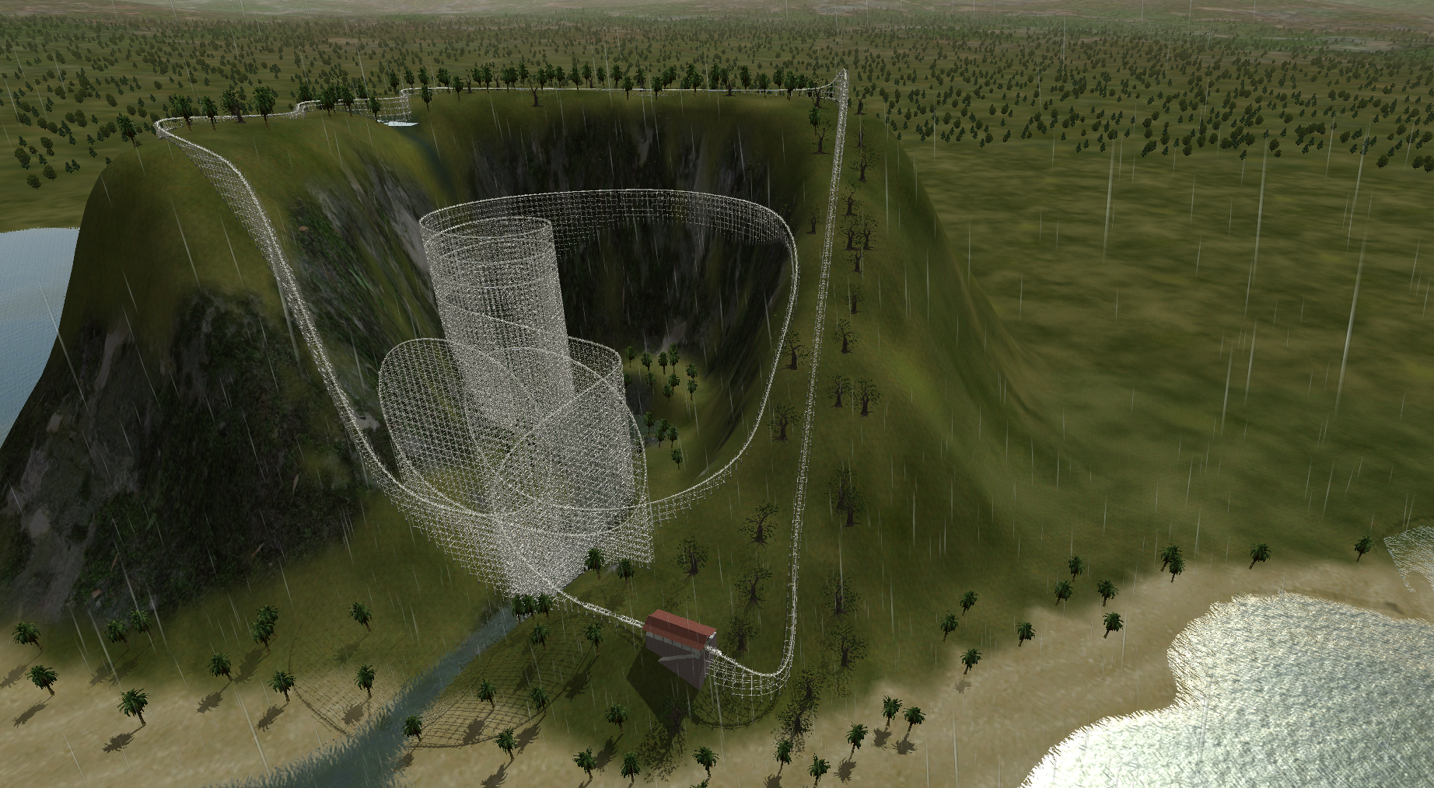

**Submitted By: PenIsland Squad**

|  |  |  |  |  |
| --- | --- | --- | --- | --- |
|  | Age | Grade | Phone Number | Email |
| Bradley Gallon (Technical) | 17 | 12 | (310) 906-6659 | bradleymoore007@gmail.com |
| Nick Mazuk (Systems) | 17 | 12 | N/A | trainridernick@gmail.com |
| Andrew Miyaguchi (Mechanical) | 17 | 12 | (424) 205-4718 | xdleader555@gmail.com |
| Elie Nehme (Manager/Business) | 17 | 12 | (310) 801-8097 | enehme46@gmail.com |

El Segundo High School

640 Main Street, El Segundo, CA 90245

(310) 615-2662

November 3, 2014

# Executive Summary

This report is a proposal by Pen Island Squad, for the bid of building a roller coaster on La Isla de Coca, in order to produce profit and increase education regarding the fields of Science, Technology, Engineering, and Mathematics. We accomplish this task through an original and abstract roller coaster, supporting the design with a complex computer simulation, giving us coordinate points, velocities, and timings along the entire track. We checked our work against international standards (such as EN 13814, the European code used by IAAPA.org, an amusement parks association). The proposed coaster would follow the theme of data management, the passage (and potential malicious action), and struggles of a single packet through the broad space known as the internet.

The coaster takes a sine wave down the top of the island waterfall, with a cubic function drop of about 120 meters. The coaster includes the required two loops right after the cubic function, which encounters a vertical G-Force of less than or equal to 9G’s. The coaster includes a spiral and an interlocking component which satisfies all constraints. In addition the coaster will be 90 cm x 78.3 cm which is well over the 50 cm x 50 cm constraint.

Our team aims to utilize our knowledge of STEM to produce a rollercoaster with an outstanding fun factor, amazing stability, and maxed speed while taking into account ecological factors, economical factors, and managing the best out of a very constrained project.

Overall, this report contains massive amounts of information regarding the literal design of the coaster, from specifics of (x,y,z) coordinates at any given moment, assuming a constant amount of time to ride the track at a specific size. We’ve taken many considerations to ensure accuracy, with a specific focus on not killing people (through extended durations of G-forces over 6 Gs). This track will not only satisfy but exceed given goals and ideals, while delighting the people riding, without hurting the local area.

Table of Contents

Executive Summary ii

1. Team Engagement 7

1.1 Team Formation and Project Operation 7

1.1.1 Team Biographies 7

1.1.2 Project Operation 8

1.2 Tool Set-up / Learning / Validation 9

2. Project Goal 12

2.1 Problem Statement 12

2.2 Design Constraints 12

2.2.1 Provided Constraints 12

2.2.2 IAAPA Constraints 13

2.2.3 Ecological Constraints 18

3. Design 20

3.1 Design Process 20

3.2 Preliminary Designing 20

3.2.1 Selecting the Theme 20

3.2.2 Preliminary Sketches 24

3.2.3 Selecting the Design 26

3.3 Detailed Design 28

3.3.1 Detailed Dimensions 28

3.3.2 Bill of Materials 29

3.3.3 Physics Analysis 30

3.4 Design Validation 35

3.4.1 Provided Constraints 35

3.4.2 IAAPA Constraints 38

3.4.3 Ecological Constraints 42

3.4.4 Testing and Validation 43

4. Business Case 46

4.1 Case for Change 46

4.2 Scope 46

4.3 Project Implementation 47

4.3.1 External Communications and Stakeholders 47

4.3.2 Advertising Campaign 47

4.4 Funding Arrangements 48

4.5 Financial Appraisal 48

4.6 Economic Appraisal 49

5. Ecological Impact 51

5.1 Summary 51

5.2 Potential Ecological Impact 51

6. Resources 53

Appendix A: Meeting Logs 55

Appendix B: Incident Report Logs 59

Appendix C: Team Terms and Conditions 60

List of Figures

Figure 1: NoLimits 2 Screenshot 11

Figure 2:F2291 - 06a - Fig. 11 16

Figure 3:F2291 - 06a - Fig. 12 16

Figure 4:F2291 - 06a - Fig. 13 17

Figure 5:F2291 - 06a - Fig. 14 17

Figure 6:F2291 - 06a - Fig. 15 17

Figure 7:F2291 - 06a - Fig. 16 18

Figure 8:F2291 - 06a - Fig. 17 18

Figure 9:F2291 - 06a - Fig. 19 19

Figure 10: Potential Design 1 25

Figure 11: Potential Design 2 25

Figure 12: Potential Design 3 26

Figure 13: Potential Design 4 27

Figure 14: Potential Design 5 27

Figure 15: Roller Coaster Dimensions 29

Figure 16: Mins/Maxes Along the Z-Axis 30

Figure 17: Horizontal X position (m), at time t 32

Figure 18: Horizontal Y position (m), at time t 32

Figure 19: Vertical Z position (m), at time t 32

Figure 20: Vertical Z position (m), at position X 33

Figure 21: Vertical Z position (m), at position Y 33

Figure 22: Horizontal Y position (m), at position X 33

Figure 23: Horizontal X velocity (m/s), at time t 34

Figure 24: Horizontal Y velocity (m/s), at time t 34

Figure 25: Vertical Z velocity (m/s), at time t 34

Figure 26: Velocity (m/s), at time t 35

Figure 27: Actual horizontal G-force, at time t 35

Figure 28: Actual vertical G-force, at time t 35

Figure 29: Track Design Constraints Compliance 37

Figure 30: Design Blueprint 38

Figure 31: Compliance of Acceleration in Given Constraints 38

Figure 32: Topography of Model 39

Figure 33: Actual Topography 39

Figure 34: Compliance of Acceleration with IAAPA Requirements 41

List of Tables

Table 1: Gantt Chart 10

Table 2: Theme Decision Matrix Part 1 22

Table 3: Theme Decision Matrix Part 2 23

Table 4: Design Decision Matrix Part 1 28

Table 5: Design Decision Matrix Part 2 28

Table 6: Bill of Materials 30

Table 7: Marble Data 45

Table 8: Materials Cost 49

Table 9: Total Construction Cost 50

# 1. Team Engagement

## 1.1 Team Formation and Project Operation

### 1.1.1 Team Biographies

Elie Nehme

*Project/Business Manager*

My speciality is the human element.  I love information with a passion and am deeply interested in the social forces/relations that support modern society. I prefer to seek out the human perspective from seemingly impersonal processes, and enjoy analyzing the underlying social, economic, and legal trends of human history and their relationship with human development.  The responsibilities and duties of my position include, but are not limited to:

* Setting team goals and coordinating efforts to achieve them.
* Maximizing productivity by mediating internal disputes
* Harmonize work conditions by providing snacks and reserving break time to reduce “burnout.”
* Maintaining morale through a calm yet passionate attitude.
* Taking lead on the business case
* Creating the gantt chart and ensuring the group stays on schedule
* Maintain meeting schedules

Nick Mazuk

*Lead Systems Engineer*

After the gauntlet of engineering that the Real World Design Challenge presents, I have gained valuable experience integrating several design components into one design. While already a project manager on several projects—such as the aforementioned Real World Design Challenge as well as the capstone project for Engineering Design and Development—systems engineering will allow me to transfer my developed skills of managing people to managing systems.

* Ensure that all members complete their tasks
* Ensure that all components work together
* Ensure a high quality of work
* Help make sure the product has a consistent look and feel

Bradley Gallon

*Lead Technical Expert*

A fine example of humankind, I am a passionate mathematician who enjoys algorithms and functionality while understanding the rationale behind life. I enjoy building with legos, making computers give me numbers I want, and have fun finding shortcuts in mathematical operations. With large amounts of experience in programming and teaching, the skills to build an online, theoretical, and working model of a calculator.

* Completes the mathematical calculations
* Ties in the model with the physics
* Ensures that the coaster meets the requirements related to math and physics
* Helps refine the design
* Completes the Spanish portion
* Ensures the citation is accurate and complete
* Working on the internet integration with Andrew
* Team DJ

Andrew Miyaguchi

*Lead Mechanical Engineer*

I love technology. I’m going to major in computer science, but I have a background in electrical and mechanical engineering as my hobbies include mainly working with my hands. I enjoy learning about electronics on my own through soldering, breadboarding, programming, or even tearing down old electronics. Also, I have interned at Northrop Grumman as the Mechanical Test Intern

* Leads the building
* Completes the CAD model on No Limits
* Coordinating the materials
* Working on the internet integration with Bradley

### 1.1.2 Project Operation

To keep the project running smoothly, we created an initial contract which we and all our parents signed. This included meeting formation, cancellation, misconduct, as well as other potential issues so we can all agree how to carry forth in the project. The current form of the contract is in Appendix C: Team Terms and Conditions.

In addition, we created a Gantt chart to plan out the entire project timeline. Up to this point, we have successfully stayed with the Gantt chart with a couple exceptions due to unforeseen delays. We have, however, always been able to catch up after each of these delays.

Table : Gantt Chart

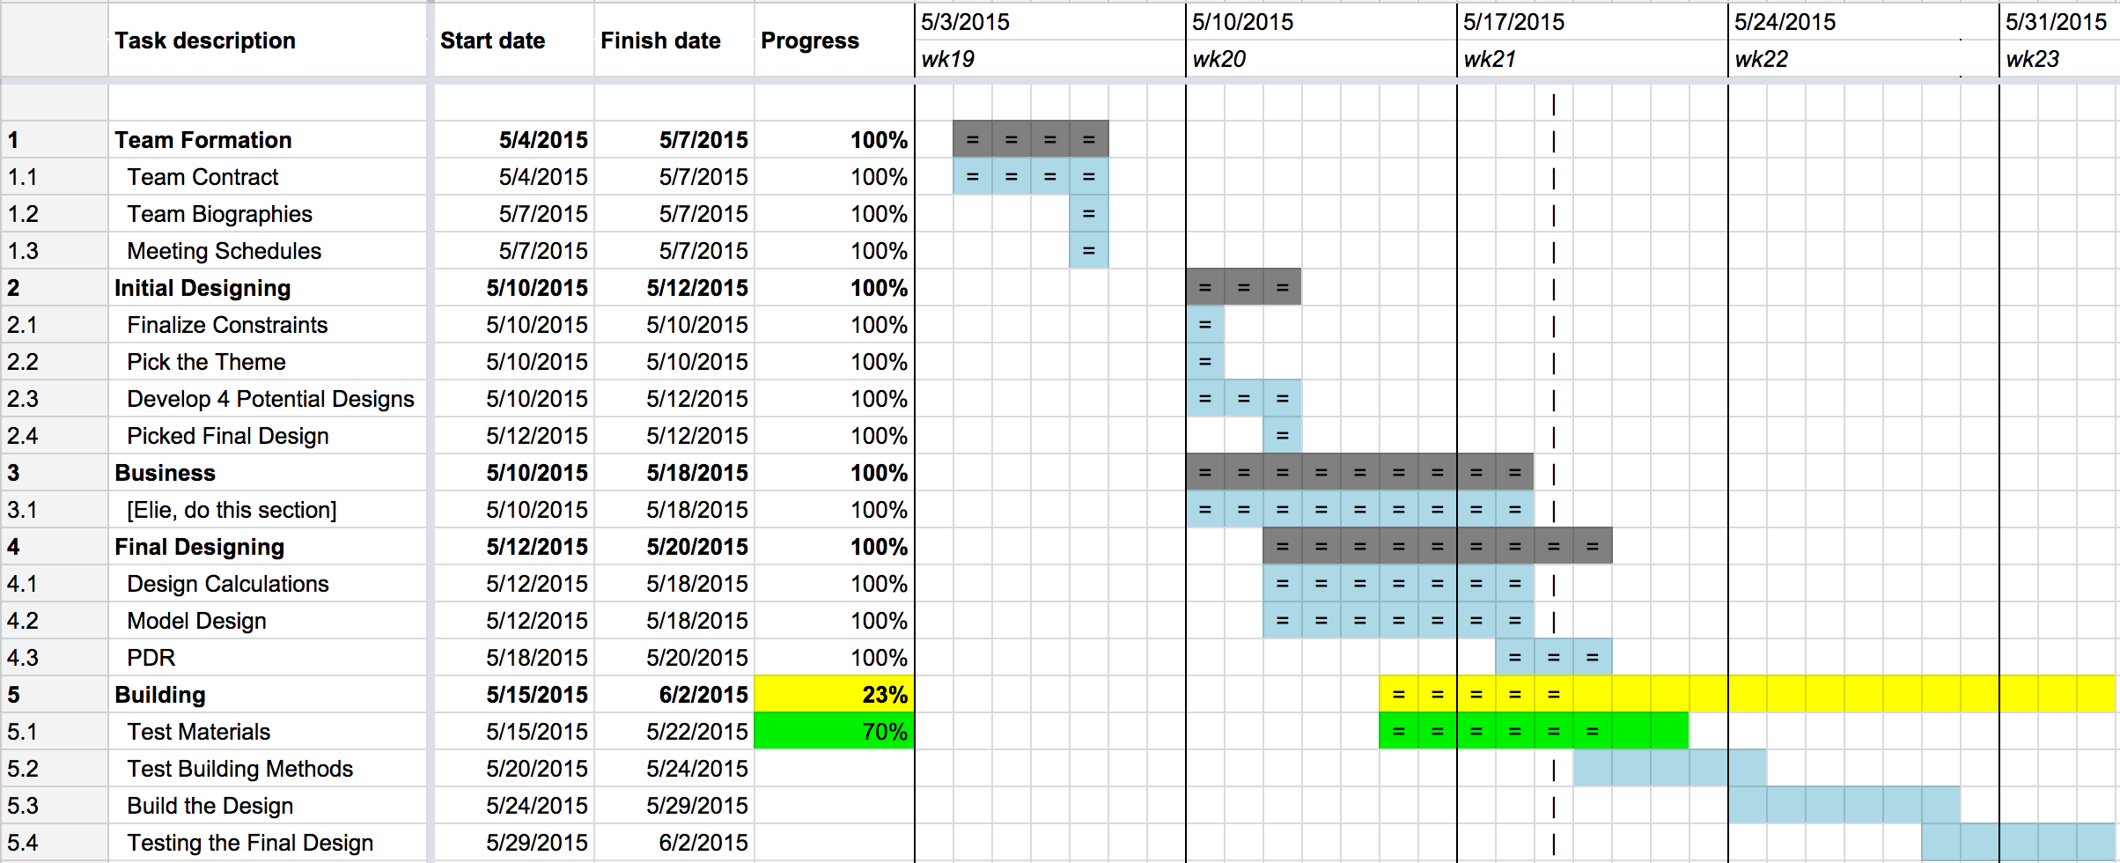

## 1.2 Tool Set-up / Learning / Validation

The required tools for this project were provided by our engineering teacher, Mr. Eno. The main program used for design, simulations, and test was NoLimits 2 (NL2). Andrew Miyaguchi was chosen to learn NL2 as quickly as possible to create an accurate model of thee rollercoaster. Installing the software was simple, using the key provided by our engineering teacher. The more difficult part of the process was to actually learn how to use it. The learning curve for NL2 was not too steep, as the controls worked much like those of a normal video game. On the other hand getting started required that a user read through the tutorial and help manuals (thankfully which was short) to fully understand and use NL2.

Autodesk Inventor is a 3D CAD modeling software which was used to create 3D parts to help with the build side of the project. Much of the CAD modeling skill required were already learned due to engineering courses at the local high school.

At first our first selection of tools to model the rollercoaster was going to be mainly Autodesk inventor, but realizing the difficulty and time required to use a CAD modeling software over a rollercoaster software which was meant to create roller coasters quickly had the team reconsider the choice of toolsets.

NL2 contained everything needed to validate any calculations made on the real life coaster, but for theoretical planning data logging was needed in order to create accurate graphs and functions. Because of a limitation in the NL2 Simulation program, the team was unable to easily log data. A program called CheatEngine was used to directly read values from the simulation program and log all the data to a console. This required specific memory addresses to be located before any data logging could begin.

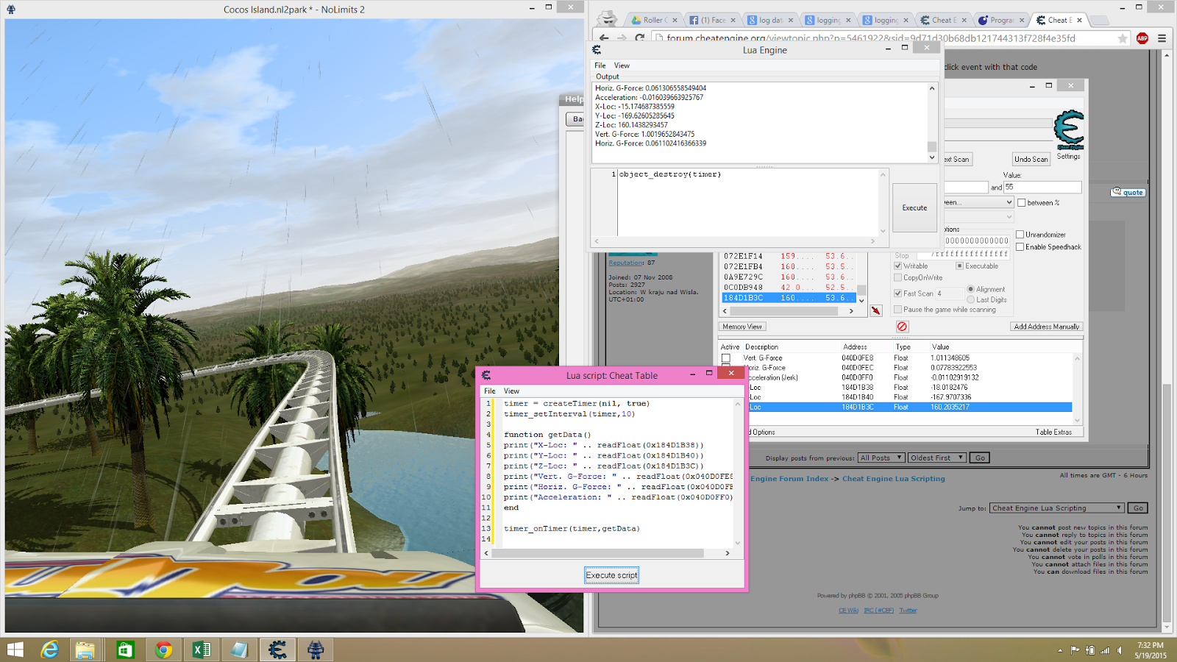

Figure : NoLimits 2 Screenshot

Certain memory addresses were easy to locate, as the “f2” button opens up the simulations panel that describes the vertical, horizontal, and jerk G-Forces. CheatEngine includes a function to search for values between two numbers, and it is already known that NL2 saves its values as floats. Once the values are found, the memory address is saved in a different box for reference in the program used to log the data.

The programming language used to log the data from CheatEngine is Lua. CheatEngine includes its own Lua scripting engine which the team took advantage of to log data to the console. The quick and simple program can be found below:

timer = createTimer(nil, true)

timer_setInterval(timer, 10)

function getData()

print("Time: " .. readFloat(0x140e04c64))

print("X-Loc: " .. readFloat(0x23e8b178))

print("Y-Loc: " .. readFloat(0x23e8b180))

print("Z-Loc: " .. readFloat(0x23e8b17c))

print("Vert. G-Force: " .. readFloat(0x045A5448))

print("Horz. G-Force: " .. readFloat(0x045A544c))

print("Jerk G-Force: " .. readFloat(0x045A5450))

end

timer_onTimer(timer,getData)

The program can be explained quickly and simply. A timer creates a loop which is run every so often. timer_setInterval sets the loop to run every 10 milliseconds. inside the loop, the function getData() is called running the commands in sequential order. The commands simply interpret the memory address as a float and prints them to the console.

The data is then sorted through using sublime text and copied to excel or google spreadsheets for further analysis. As the timer on CheatEngine is not very accurate, an ingame timer is captured to ensure the accuracy of the points logged. It is, however, known that our data is sampled roughly every 10 milliseconds further increasing accuracy.

# 2. Project Goal

## 2.1 Problem Statement

The Costa Rican tourism industry is booming, but with the opening of Jurassic World on Isla Nublar there is a huge new player taking a big part of the market share. PenIsland Squad has been commissioned by the Costa Rican Government to develop an educational theme park on the Isla del Coco. Since this island is a national park with important ecosystems they do not want any major modifications to the island or to the plant and animal life living there. Each group must find a part of the island where they will build their coaster and have a STEM topic that will be taught through the coaster. The coaster must cover less than 1/10 of the island and can only be built 300 m higher than the elevation. All coasters must meet the standards set by the International Association of Amusement Parks and Attractions (IAAPA). Along with the proposal, there will need to build a scale model where 1cm = 10m. The proposal shall convince the government that the design is eco-friendly, will inspire riders to learn STEM, will increase tourism, and has a sustainable business model.

## 2.2 Design Constraints

### 2.2.1 Provided Constraints

1. The roller coaster shall not cover more than 1/10 of the island (238,500 m2).
   1. Maximum dimensions for a square: 1,550 m x 1,550 m
2. The height of the roller coaster at any point shall not exceed 300m above the terrain.
3. The design shall comply with all IAAPA standards.
4. The construction and operation of the coaster should not interfere with the local ecosystem.
5. The roller coaster should be appealing and attractive to a wide audience.
6. A suitable and practical business plan shall be included along with the actual design.
7. The model shall have the minimum dimensions of 50 cm along both the x and y directions perpendicular to each other, both parallel to the earth.
8. The base shall be made of solid wood.
9. The model and coaster must be a continuous track, and must be differentiable at every point.
10. The final coaster, not necessarily the design, shall be a wooden roller coaster.
11. The coaster must include, along its track:
    1. 2-loops
    2. 1 spiral/corkscrew
    3. 2 interlocking elements
    4. 3 different/distinct functions (minimum 2 periods of a sine or cosine)
12. A complete blueprint must be generated.
13. At some point along the track, the cart/marble must experience at least 2Gs, and at another point less than 0.5Gs.
14. The model must reliably work with 10 consecutive activations, performed by the judges.
15. The model should accurately represent the topography of the construction zone.
16. The track should make an optimal use of the land it is built on.

### 2.2.2 IAAPA Constraints

These constraints were taken from another source, based on EN 13814 which is where IAAPA takes its regulations, along with ISO 9001 (both international standards, with EN 13814 being the standard for European amusement parks).

* *5.2.1.4 Calculations shall be performed using coordinate axis and load paths as defined by Practice F 2137 or the EN equivalent, (x,y,z) ie: x and y are both parallel to the ground, perpendicular to each other, while z is vertical*
* *5.4.1 The designer/engineer or manufacturer shall produce and retain as-built drawings, calculations, and control software that depict the amusement ride, device, or major modification details. These drawings and calculations shall be retained for a minimum of 20 years from the date of last manufacture. In the case of a major modification, only the records associated with that major modification, and not the entire ride or device, must be retained for a minimum of 20 years.*
* *5.4.4.3 Detailed drawings of all components specifically manufactured for use in the amusement ride, device, or major modification.*
* *5.5.1 When the approval of the amusement ride, device, or major modification design is required by a regulatory authority, the following documents are typically  made available for review:* 
  + *5.5.1.1 General assembly drawings,*
  + *5.5.1.2 Facility interface drawings and related load calculations,*
  + *5.5.1.3 Operations, maintenance, and assembly instructions*
* *6.3.8.3 Special tools shall not be required to operate the manual release,  unless otherwise determined by the  ride analysis.*
* *7.1.4.5 The limits specified for all axes are for total net acceleration, inclusive of earth's gravity. A motionless body would therefore have a magnitude of 1 G measured in the axis perpendicular to the earth's surface, and a 0 G magnitude in the axes parallel to the earth's surface.*
* *7.1.6.1 The peak-to-peak transition time between consecutive sustained events in X and Y accelerations shall be greater than 200 ms, as measured by the time between the peaks of the consecutive events. When the elapsed time between consecutive sustained events is less than 200 ms, the limit for the peak values shall be reduced by 50 %.*
* *7.1.7.2 Other transitions in Z accelerations are shown in Fig. 20. The following criteria shall apply: When transitioning from sustained weightless (0 G) and more negative levels to 2 G and more positive levels, the effective onset of positive G shall be less than 15 G/s. Fig. 20 illustrates such transitions.*
* *7.1.8 Measurement and analysis of acceleration on amusement rides and devices shall be performed in accordance with Practice F 2137. The design acceleration levels  of the  final operational assembly of a newly developed amusement ride, device, or major modification shall be verified at commissioning. The manufacturer may verify acceleration limits herein by using either manual (for example, graphic, hand calculations, and so forth) or automatic (for example, computational, computer, and so forth) procedures.*
* *F2291 - 06a - Fig. 11-18*

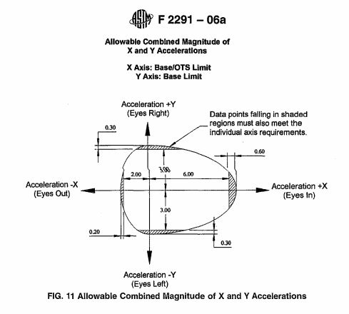

Figure :F2291 - 06a - Fig. 11

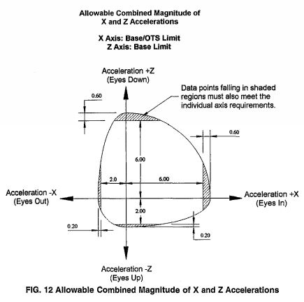

Figure :F2291 - 06a - Fig. 12

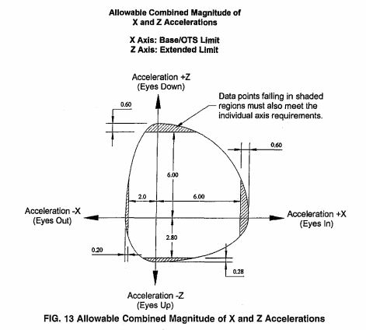

Figure :F2291 - 06a - Fig. 13

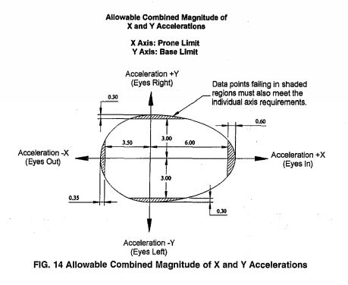

Figure :F2291 - 06a - Fig. 14

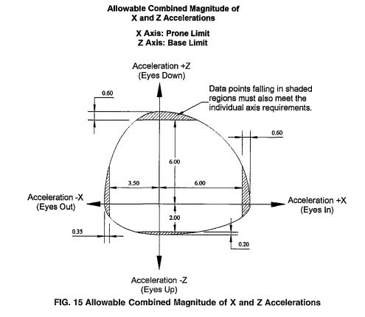

Figure :F2291 - 06a - Fig. 15

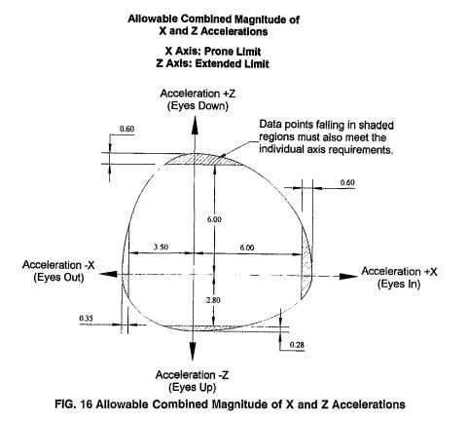

Figure :F2291 - 06a - Fig. 16

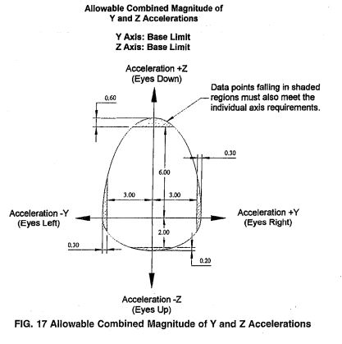

Figure :F2291 - 06a - Fig. 17

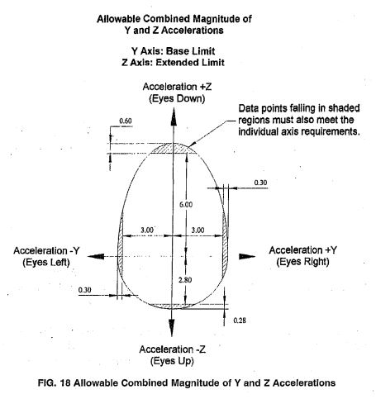

Figure :F2291 - 06a - Fig. 19

* *8.33.4.1 Inspection for damaged or missing paint and the   
  presence of moisture; any situations where water might enter and become trapped,  supporting the  development of rot or insect damage, or failure from expansion due to ice formation, and recommended methods of examinations required to determine the presence and extent of rot in timber members.*
* *13.2.2 Chain and related accessories shall be selected and designed for designer/engineer specified loads, speed, corrosion, operating environmental and dynamic conditions, and for wear and fatigue.*
* *13.2.3 Chain manufacturer's specifications shall include dimensions, strength,  grade, and nominal breaking strength working load limit, and shall be included in the maintenance instructions.*
* *13.2.4 The capacity of the chain and related accessories, for example, terminations, adapters, shall be verifiable by certificates, manufacturer's markings, or testing.*

### 2.2.3 Ecological Constraints

1. *The coaster shall not disturb any plants or animals in such a way that a decrease in population, food supply, or water supply could upset the ecosystem or endanger any plants or animals.*
2. *The coaster shall not pollute any water sources with any foreign chemicals.*
3. *Only the plants necessary for building the roller coaster or rider safety shall be removed. Additionally, this number shall be kept at a minimum.*
4. *The type of materials used shall not be able to affect the surrounding ecosystems.*
5. *The coaster shall not produce an excess of 5 tons per year of*
   1. *carbon monoxide*
   2. *lead*
   3. *nitrogen oxides*
   4. *particulate matter (TSP or total suspended particulates)*
   5. *sulfur dioxide*
   6. *volatile organic compounds (VOCs)*
   7. *toxic air pollutant*

# 3. Design

## 3.1 Design Process

The design of this roller coaster follows a very typical design process that closely aligns with the PLTW Engineering Design Process:

1. Team Formation
2. Defining the Problem
3. Brainstorming
4. Researching
5. Explore Possibilities
6. Select an Approach
7. Develop the Design
8. Build and Test the Design
9. Communicate the Results

By using this design process, it ensures that the final solution is the optimum solution for the task.

## 3.2 Preliminary Designing

### 3.2.1 Selecting the Theme

To create the maximum opportunity to select an optimum theme, 12 potential theme ideas were brainstormed with the only restriction being that every idea recorded (not necessarily discussed) had to relate to STEM in some way. This way could, for the purposes of brainstorming, be as convoluted or blatant as possible. Below is the list of the 12 ideas:

1. Biodiversity
2. Ecology
3. Law of conservation of energy / momentum
4. Internet data transfer
5. Evolution of technology
6. Use evolution of life as a metaphor of technology
7. History of roller coaster design
8. Molecular structures of chocolate
9. History of design of amusement parks
10. Insulting Spain
11. Social curve
12. History of the indigenous engineering

After brainstorming, we put all of these ideas into a decision matrix and selected the top three to elaborate on further than what we discussed. Below is the decision matrix (sorted by total points, each receiving a rank 1-12 relative to the other ideas):

Table : Theme Decision Matrix Part 1

|  |  |  |  |  |  |
| --- | --- | --- | --- | --- | --- |
| Themes | General Opinion | Enthusiasm | Execution | Application to Coaster | STEM Relation |
| Internet | 12 | 12 | 8 | 11 | 11 |
| Evolution of Tech | 11 | 9 | 11 | 8 | 12 |
| Conservation (E/p) | 10 | 11 | 12 | 12 | 10 |
| Ecology | 4 | 6 | 10 | 4 | 9 |
| Social Curve | 9 | 8 | 4 | 9 | 7 |
| Life/Tech Metaphor | 8 | 7 | 7 | 7 | 6 |
| Biodiversity | 5 | 5 | 9 | 3 | 8 |
| Chocolate | 7 | 10 | 3 | 2 | 4 |
| Roller Coaster Design | 2 | 2 | 6 | 10 | 3 |
| Insulting Spain | 6 | 4 | 1 | 1 | 1 |
| Amusement Parks | 1 | 1 | 5 | 6 | 2 |
| History of Engineering | 3 | 3 | 2 | 5 | 5 |

Table : Theme Decision Matrix Part 2

|  |  |  |  |  |
| --- | --- | --- | --- | --- |
| Practicality | Reaction to Judges | Entertaining Value | Relevance to Costa Rica | Total |
| 11 | 12 | 12 | 8 | 97 |
| 10 | 10 | 7 | 7 | 85 |
| 12 | 11 | 1 | 1 | 80 |
| 8 | 6 | 8 | 10 | 65 |
| 6 | 8 | 11 | 3 | 65 |
| 5 | 5 | 6 | 9 | 60 |
| 7 | 7 | 3 | 11 | 58 |
| 3 | 9 | 10 | 6 | 54 |
| 9 | 3 | 5 | 5 | 45 |
| 1 | 1 | 9 | 12 | 36 |
| 4 | 2 | 4 | 4 | 29 |
| 2 | 4 | 2 | 2 | 28 |

The detailed ideas are as follows:

* Internet
  + The internet is a broad subject, and explaining it could be done with our new ride: “THE PACKET”, a ride simulating the travel of a lone internet packet through the vast space known as the interwebs. Fly through our new age tech coaster, experiencing the challenges that face each packet, from firewalls, to routers, modems, ethernet and fiber cables, all the way to the final destination: The Client. Enjoy our interactiveness through inclusion of participation from ESHS Gaming International, and please come try our thrilling and suspenseful experience, “THE PACKET”.
  + In terms of actual execution, this will be built on a techy model, with as many computer and internet references as we can include, alongside ideally and end goal some interactivity with our local website [ESHS Gaming](http://www.eshsgaming.com).
  + The design will be built on a standard plywood board, with triggers at both the beginning and end. Built possibly out of computer towers and old modems, securely fastened down, this idea is the one that we can be the most creative with by far, along with have a high level of enthusiasm for.
* Conservation of Energy and Momentum
  + In terms of execution, this idea is the most related to physics, reasonably easy to explain, and by far easiest to demonstrate as a project. We would probably include as many physics references as we can, from Einstein to F=ma, to everything that Eno so amazingly inspired us to learn about.
  + For design, lots of physics references, possibly having 2 charts side by side at various points that show the kinetic and potential energy of the marble at any point. Overall, connecting the theme to the actual coaster would not be too tough.
* Evolution of Tech
  + The general evolution of technology, from the primitive tools of the Stone Age to the complex digital infrastructure of the modern world, and a glimpse at what the future may hold (nanotechnology, nuclear fusion, human colonies on Mars, etc).
  + Divided into four phases, branching from the hunter-gatherer gadgets of our ancestors, to the Industrial Revolution of the 18th and 19th century (complete with steam engines, locomotives, and telegraphs), to the modern age, with references to the leaps in digital technology, the rise of cell phones and smartphones, and a look at the Web.
  + Finally, a glimpse at the future: optimized nanotechnology, spacecraft that fly across the galaxy, and mobile robots that look like and talk like humans. A “Tomorrowland” for the 21st century.

After submission of these ideas to Mr. Eno, we were given the internet as our theme. When Ms. Clemmer returned, however, she suggested a more focused theme than the internet, possibly software related instead of hardware. After some discussions, the theme became focused on internet data transfer and how the data can possibly be manipulated maliciously by a third party.

Later, with the added challenge of adding innovation into the theme, we decided to add the art of wiretapping to show the insecurities of current data transfer. The wiretapping will occur towards the end where, after all the security features, someone is able to steal the data without the user being noticed. This stolen data will then interact with the final trigger mechanism.

### 3.2.2 Preliminary Sketches

After refining the constraints in the problem statement, several possible coasters were sketched. The following are the sketches:

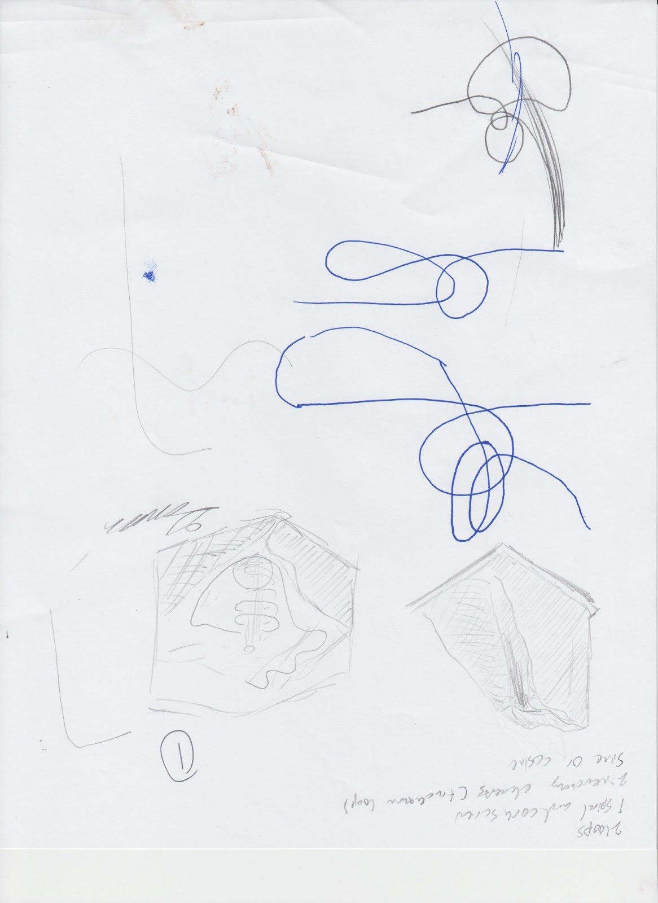

Figure : Potential Design 1

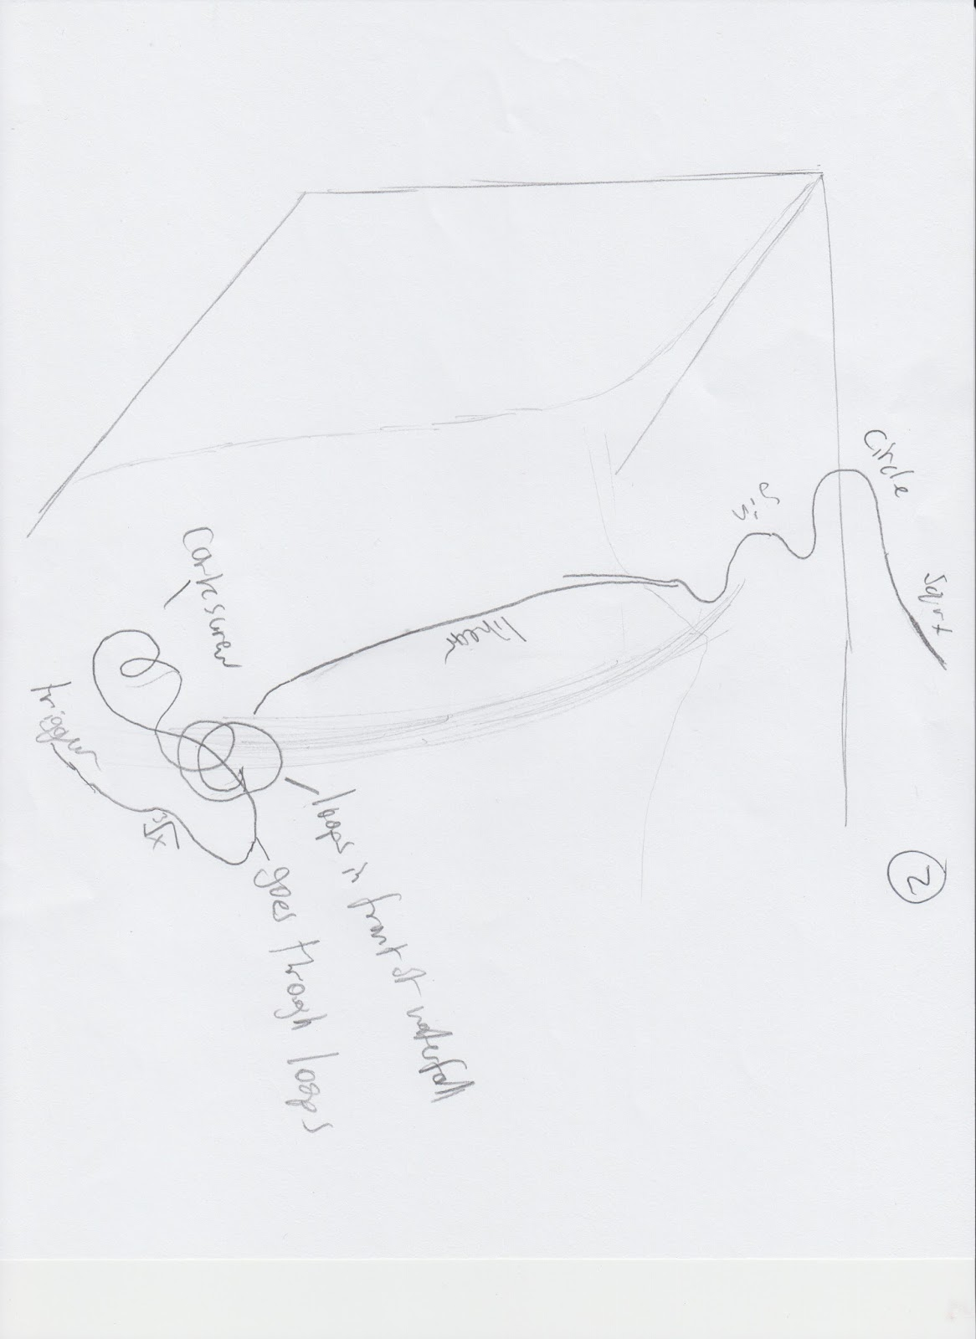

Figure : Potential Design 2

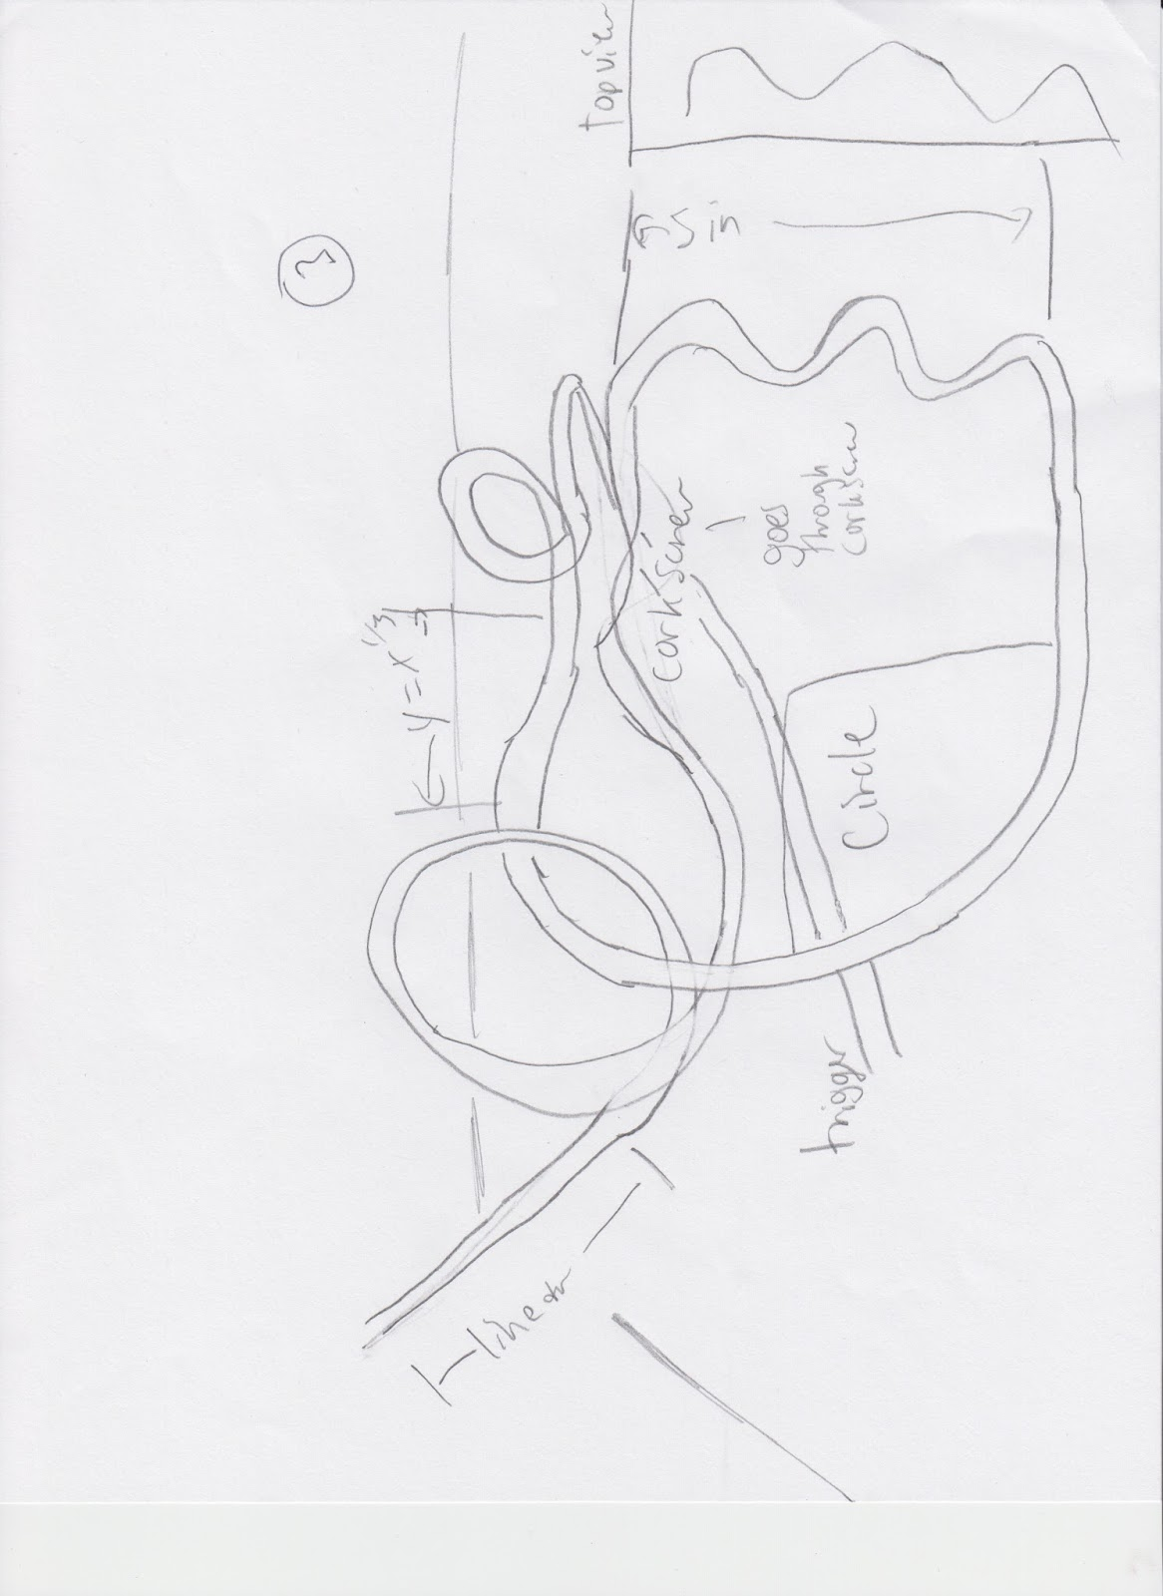

Figure : Potential Design 3

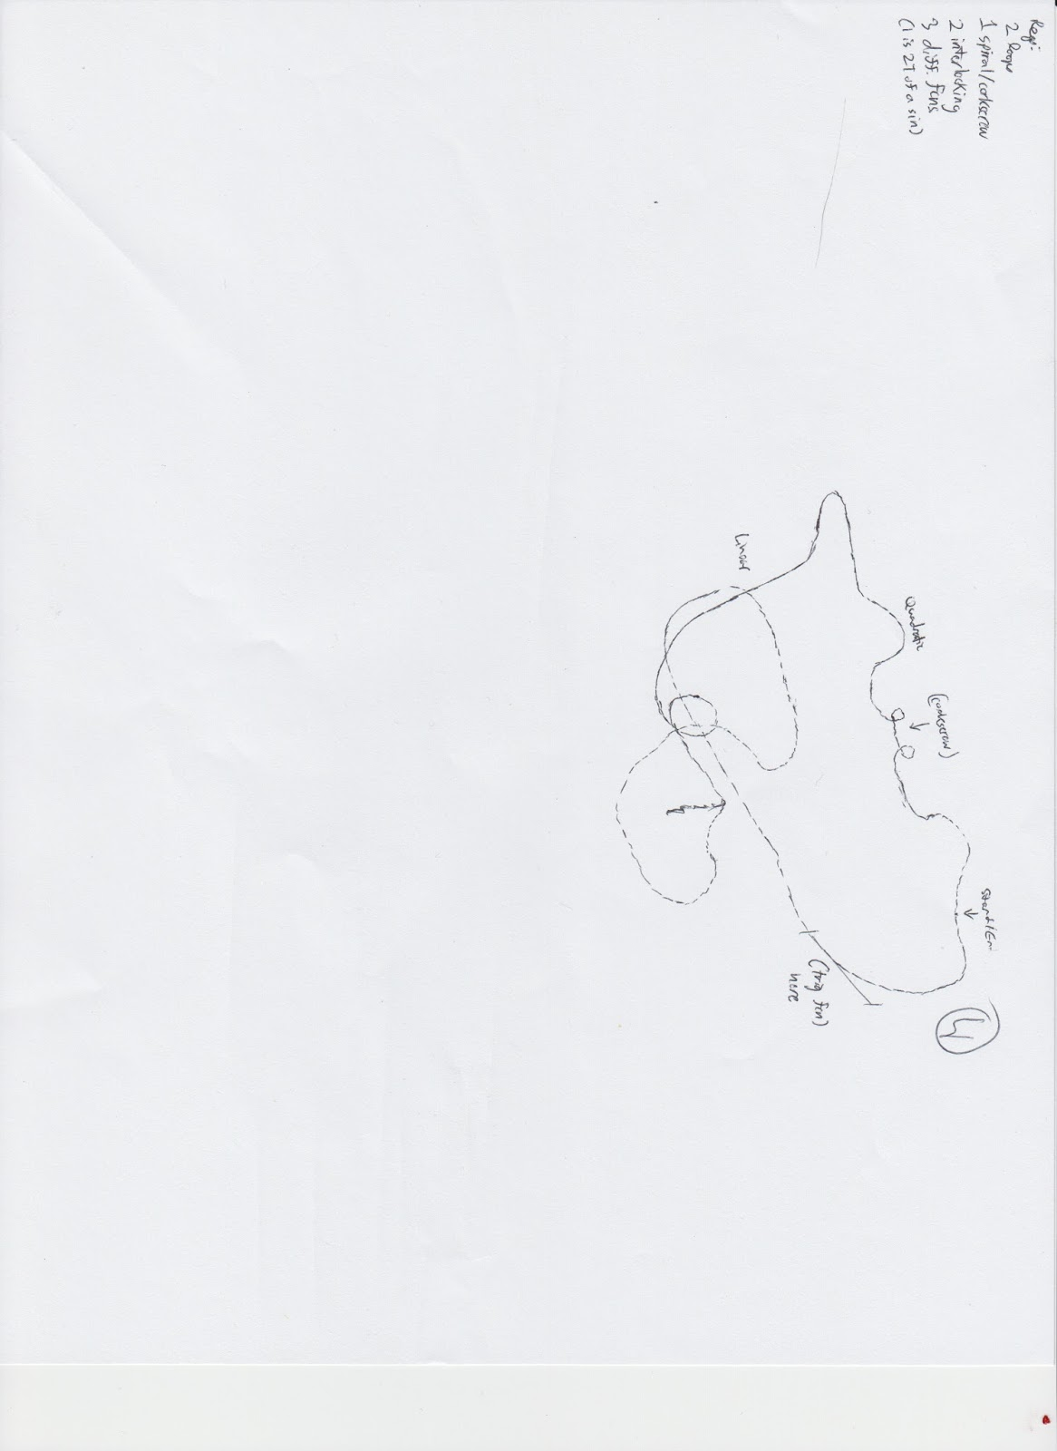

Figure : Potential Design 4

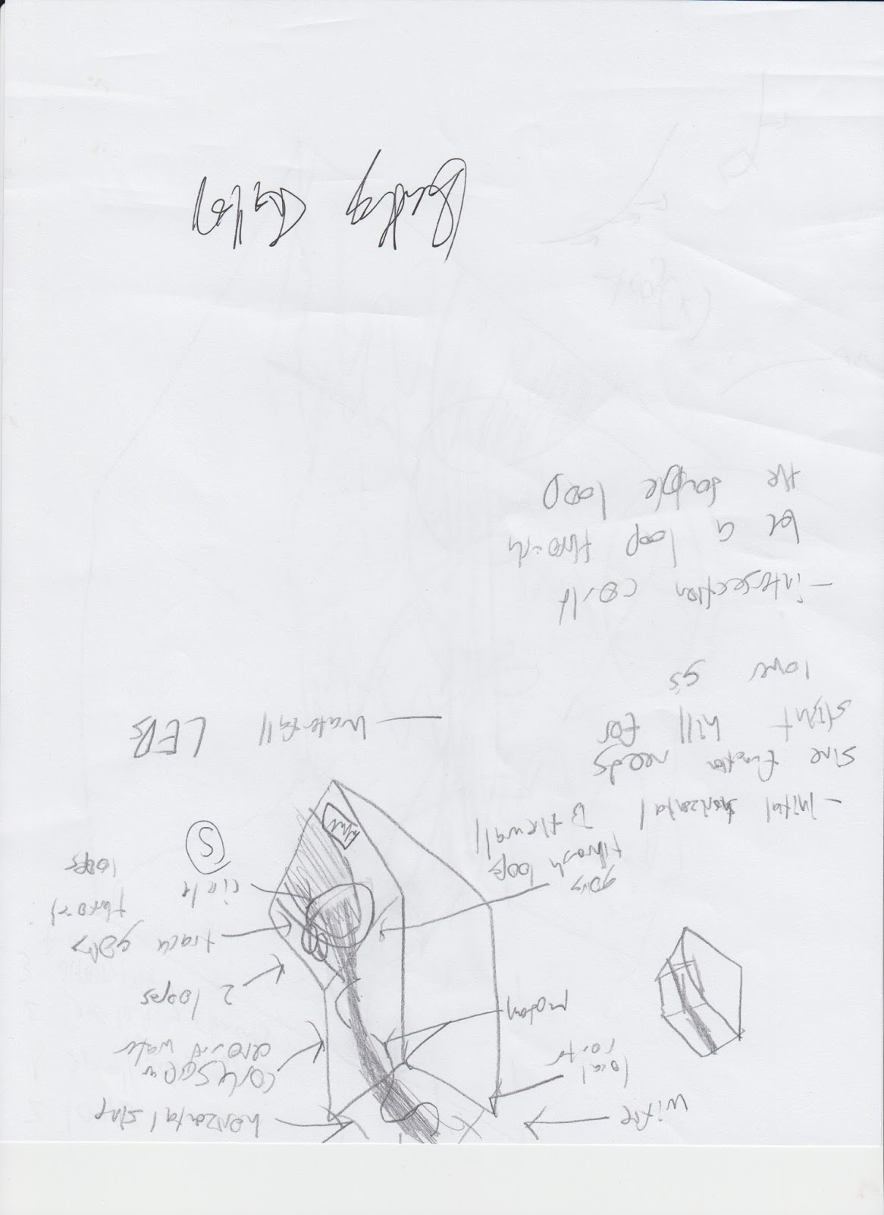

Figure : Potential Design 5

### 3.2.3 Selecting the Design

The possible designs were then put into a decision matrix.

Table : Design Decision Matrix Part 1

|  |  |  |  |  |
| --- | --- | --- | --- | --- |
| Idea | Enthusiasm | Feasability | Meets Requirements | Originality |
| 1 | 5 | 3 | 5 | 3 |
| 2 | 3 | 4 | 5 | 3 |
| 3 | 2 | 3 | 5 | 5 |
| 4 | 1 | 5 | 5 | 3 |
| 5 | 5 | 3 | 5 | 3 |

Table : Design Decision Matrix Part 2

|  |  |  |  |  |
| --- | --- | --- | --- | --- |
| Fun | Env. Impact | Optimized Area | Maximize v/a and jerk | Total |
| 5 | 2 | 5 | 5 | 33 |
| 5 | 3 | 1 | 5 | 29 |
| 4 | 3 | 1 | 5 | 28 |
| 3 | 4 | 1 | 5 | 27 |
| 5 | 2 | 4 | 5 | 32 |

The designs were judged on several categories to determine which one was the best solution. The first, enthusiasm, related to our personal enthusiasm of building the design. If we were not enthusiastic about the design, it would become more difficult to want to produce a quality product. Secondly, the designs were judged on feasibility to determine how likely it was that the model could be built of these designs. Next was the requirements. As each of the designs were not tested yet, the meeting of the requirements was all based off of estimations. The originality was based on how much the design did not look like the straightforward answer. This had nothing to do with simplicity. The greater the originality of a design, the greater the interest would be for both a rider and a builder. The next was how fun the design would be based on personal experiences of riding roller coasters. The seventh requirement was the environmental impact. Again, since this was estimates, it was entirely based on how much of the environment the roller coaster took up. This is similar to the next requirement about optimized area. The more compact the coaster, the better. The final criterion is that velocity, acceleration, and jerk are maximized. This was based on previous physics knowledge and intuition.

## 3.3 Detailed Design

### 3.3.1 Detailed Dimensions

The rollercoaster computer model takes up a rectangular prism with a length of 300 meters, a width of 261 meters, and a height of 172 meters.

The diameter of both loops is about 70 meters, with the center of the loops about 75 meters above sea level.

The length of the sine function is about 180 meters long, with an amplitude of about 30 meters.

The diameter of the spiral is 60 meters, with the spiral circling around three complete times.

The estimated length of track is 2701.49 meters.

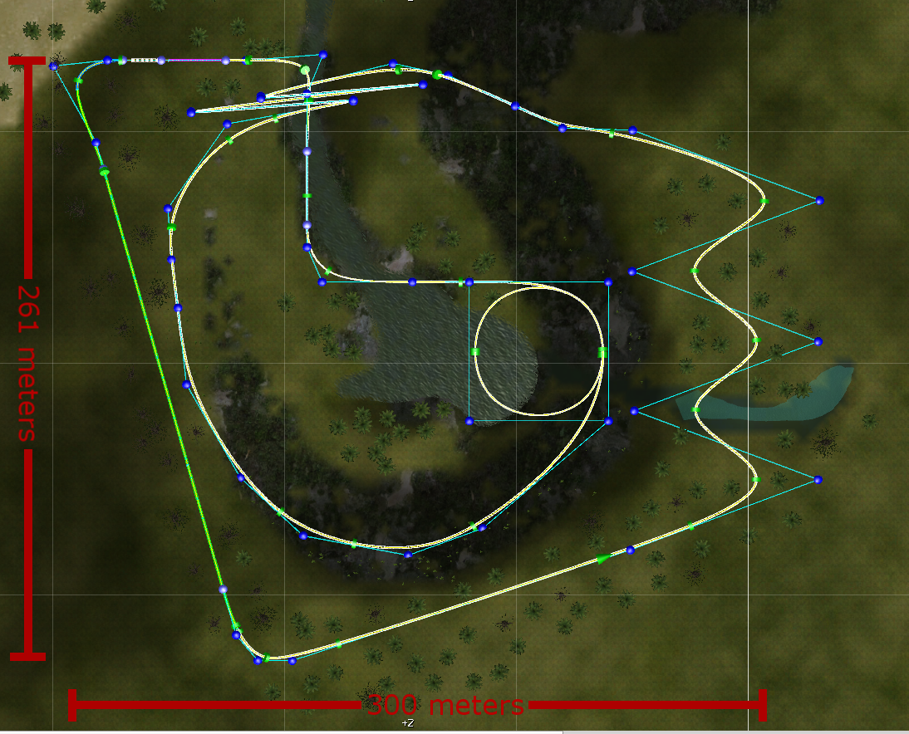

Figure : Roller Coaster Dimensions

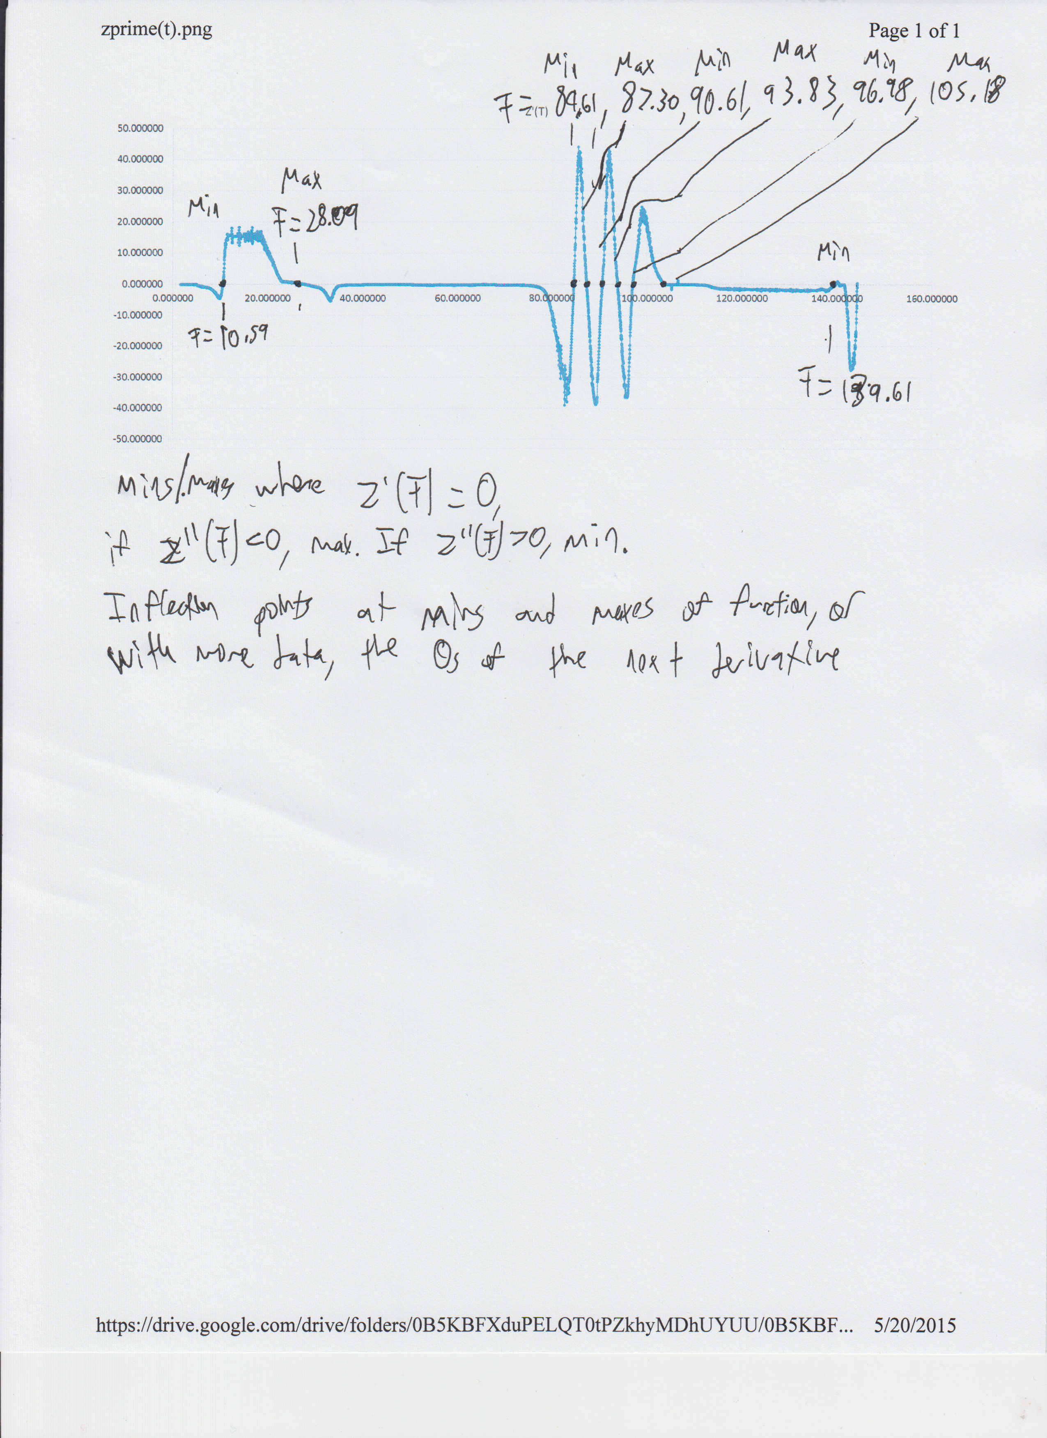

Figure : Mins/Maxes Along the Z-Axis

### 3.3.2 Bill of Materials

A sample build of materials was generated for a quick estimation of project costs for the marble roller coaster. Some of the materials had already been bought, or are available for use for free at the high school engineering lab which will greatly decrease costs. Equipment such as a soldering iron or heat gun are already owned by one or more of the team members. Prices are obtained through amazon, Home Depot, or their respective sources.

Table : Bill of Materials

|  |  |  |  |
| --- | --- | --- | --- |
| Name | Quantity | Price per | Sub Total |
| 48"x48" Plywood | 1 | $8.75 | $8.75 |
| Cabinet Handles | 4 | $1.78 | $7.12 |
| Marbles (24ct) | 3 | $5.25 | $15.75 |
| Wooden Coffee Stirrers (1000) | 1 | $5.60 | $5.60 |
| Coffee Straws/Stirrers (1000) | 1 | $5.05 | $5.05 |
| Soldering Iron | 1 | $93.37 | $93.37 |
| Heatgun | 1 | $34.99 | $34.99 |
| Wooden Dowels 1/2"x36" | 5 | $1.50 | $7.50 |
| Poultry Netting | 1 | $26.00 | $26.00 |
| Spray Paint | 1 | $4.99 | $4.99 |
|  |  | Total | $209.12 |

Some questionable items such as Poultry Netting is required, as they have some use in our project. Poultry Netting specifically will be used to create a frame for the topography model of the Island.

### 3.3.3 Physics Analysis

We were able to log certain data from a simulation of riding the model, taking the (x,y,z) coordinate of the cart every 10ms, along with the engine’s calculated velocity, acceleration, and jerk. We checked these numbers by calculating the theoretical velocity, acceleration, and jerk at every point, but didn’t have enough accuracy to show the actual acceleration or jerk at every point.

Through breaking the model down into 3 separate axes as defined by EN 13814 5.2.1.1, we then produced 3 separate functions showing x, y, and z each as functions of time.

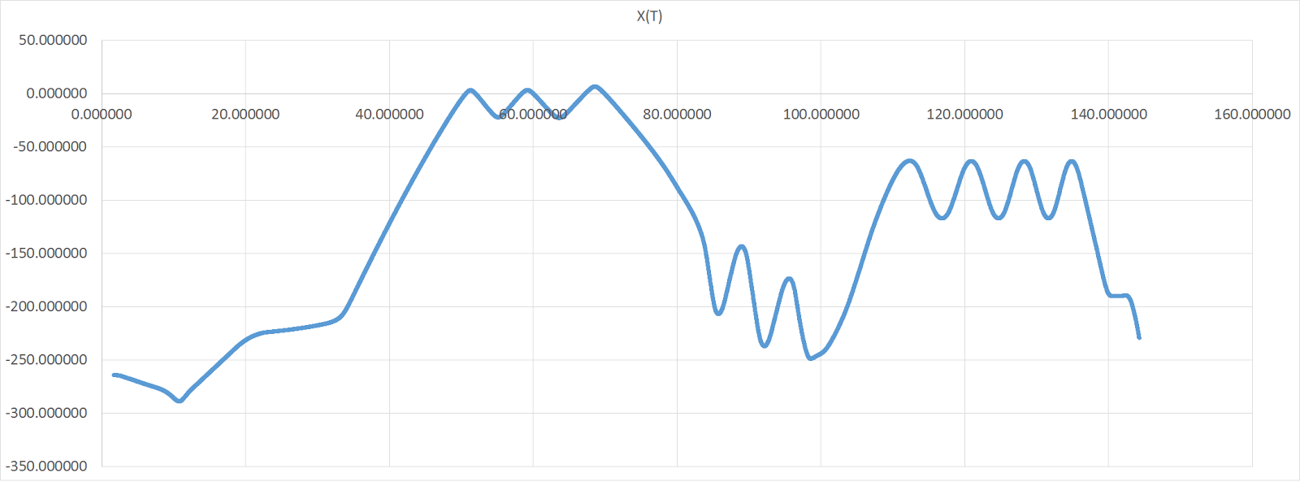

Figure : Horizontal X position (m), at time t

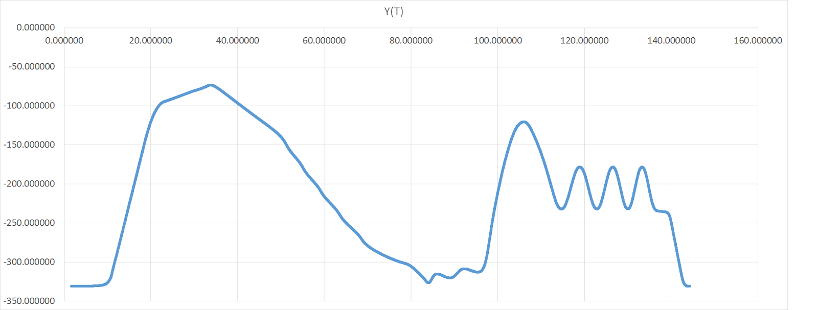

Figure : Horizontal Y position (m), at time t

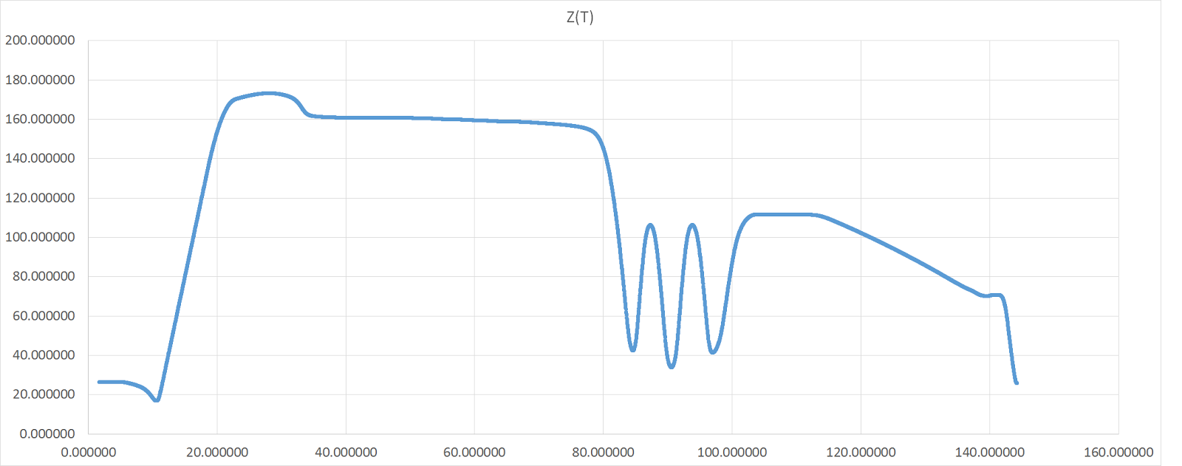

Figure : Vertical Z position (m), at time t

These graphs were very in sync with the model and our design, showing the position at any point, allowing the entire model to be plotted and recreated from this information alone.

We also graphed height Z as a function of position X along with position Y, effectively giving us perfect side views of the model.

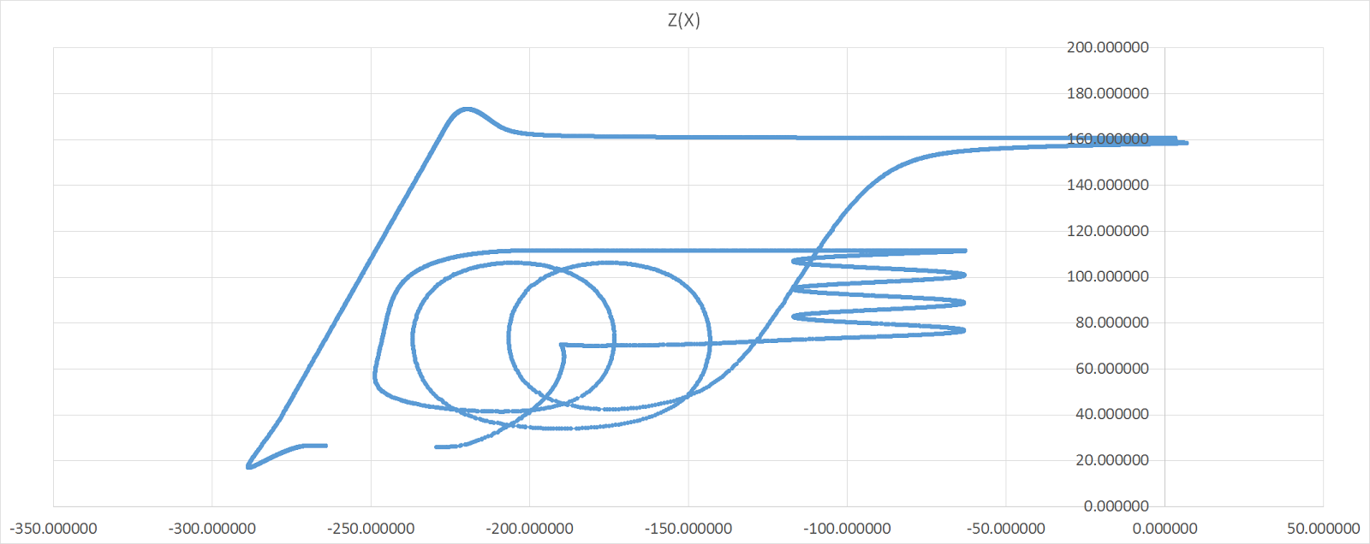

Figure : Vertical Z position (m), at position X

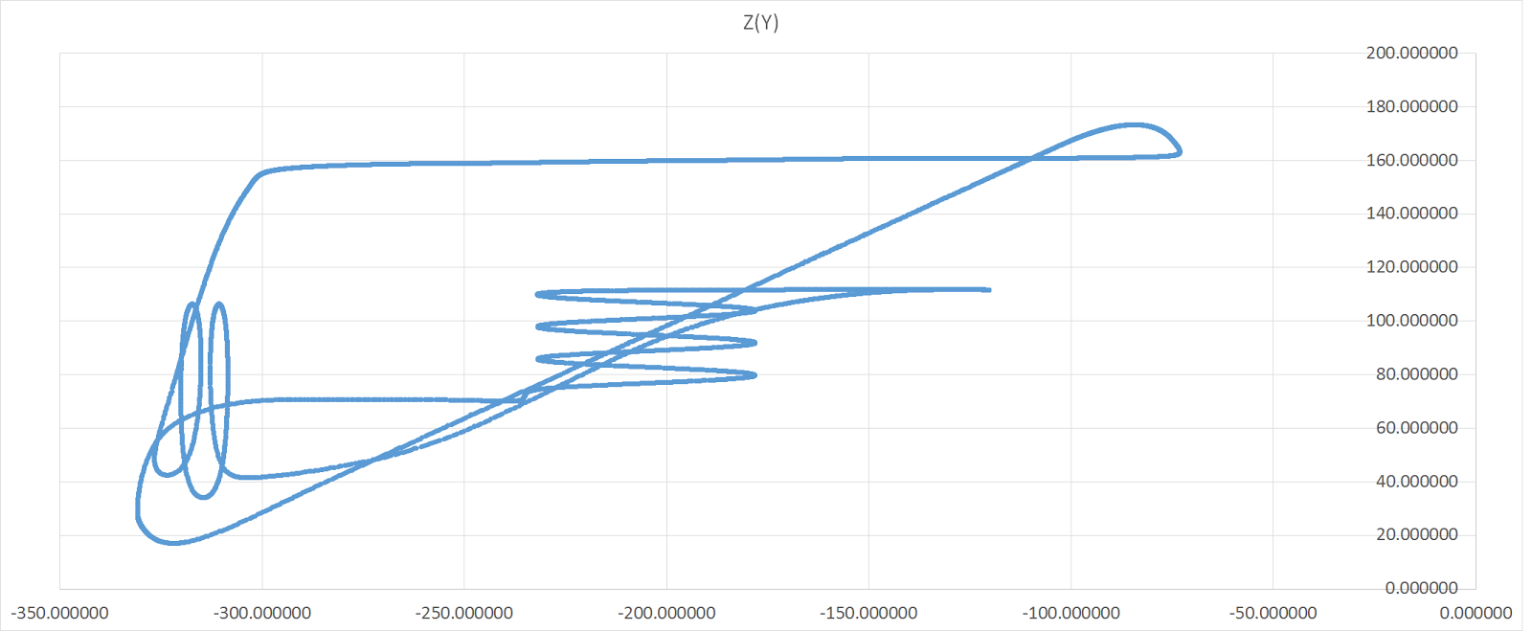

Figure : Vertical Z position (m), at position Y

Our final visual representation of the model and its position, was a graph of position Y as a function of position X, effectively giving us a “top-down” view on the roller coaster.

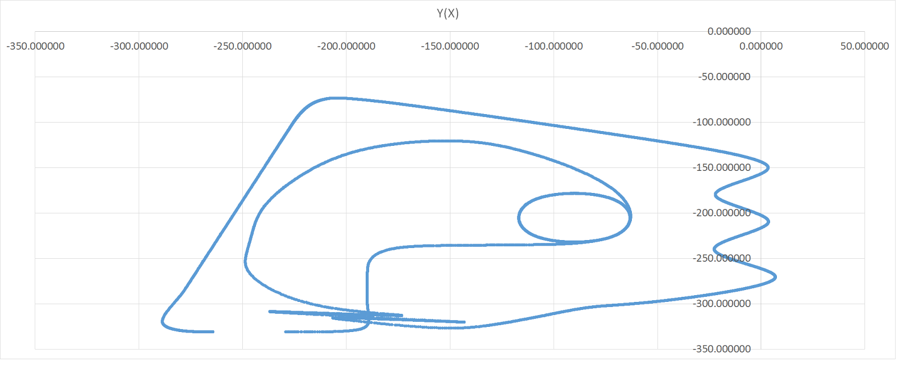

Figure : Horizontal Y position (m), at position X

This information was very consistent with our simulated model, with the top down and side views looking nearly identical to the model, so we calculated the velocity along each cardinal axis, which was something the simulation did not give us.

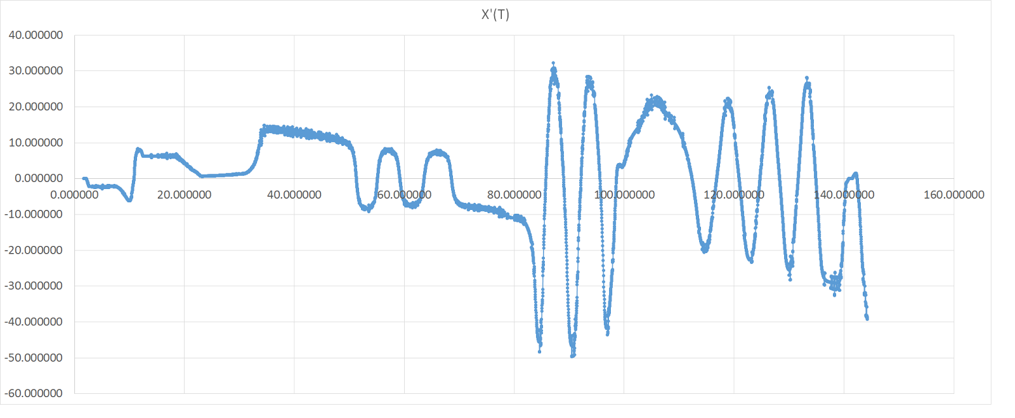

Figure : Horizontal X velocity (m/s), at time t

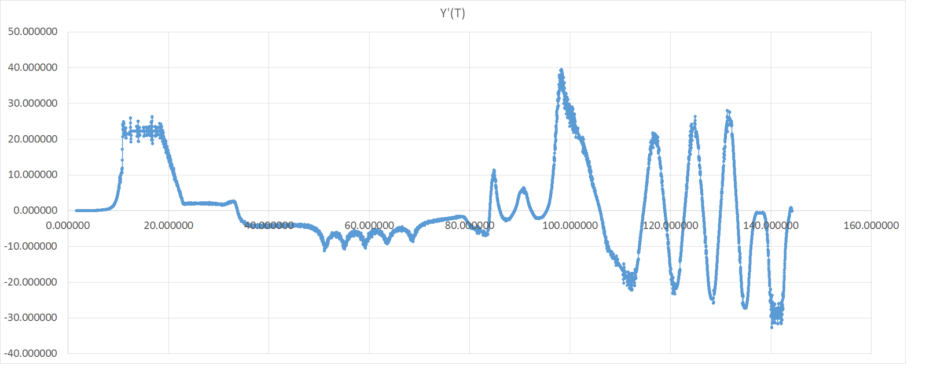

Figure : Horizontal Y velocity (m/s), at time t

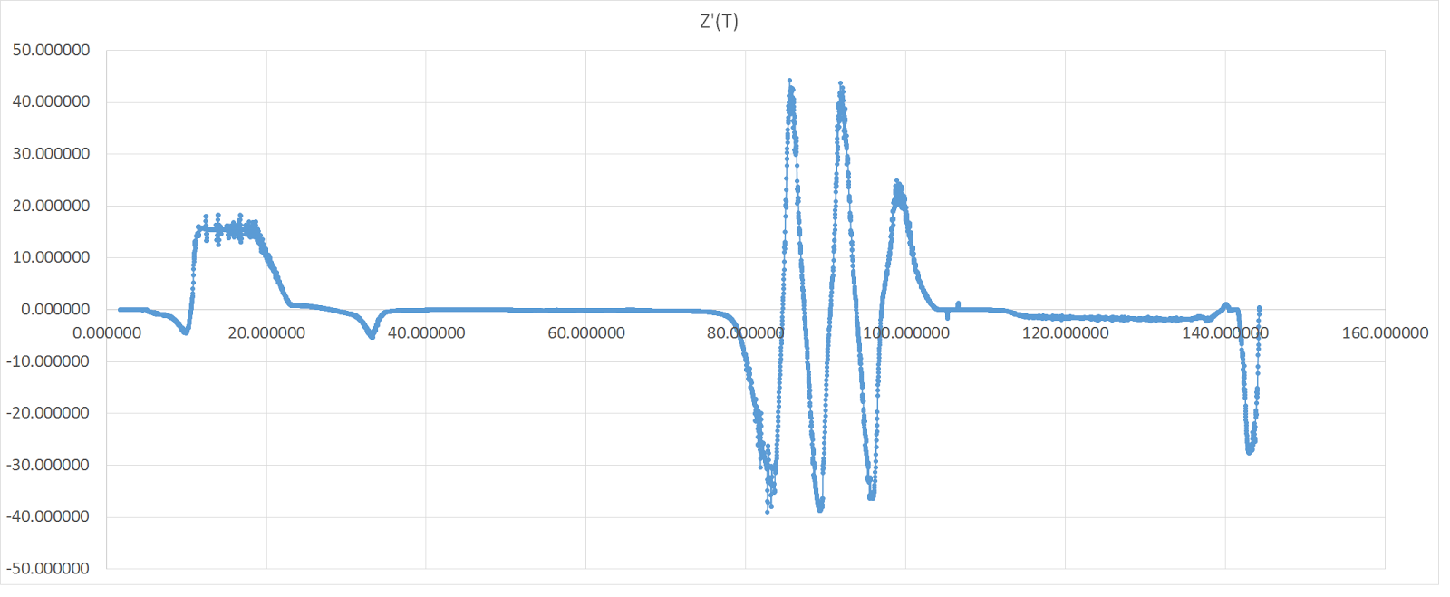

Figure : Vertical Z velocity (m/s), at time t

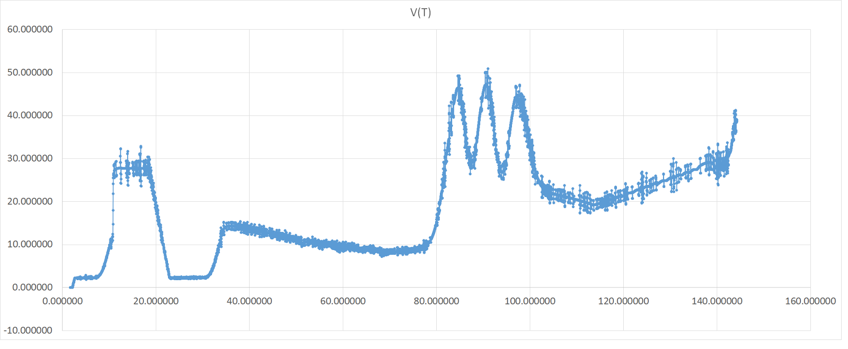

Figure : Velocity (m/s), at time t

At this point, our coordinate points were not accurate enough to calculate the acceleration of the the cart along each cardinal axis, but the simulation does provide horizontal and vertical G-forces.

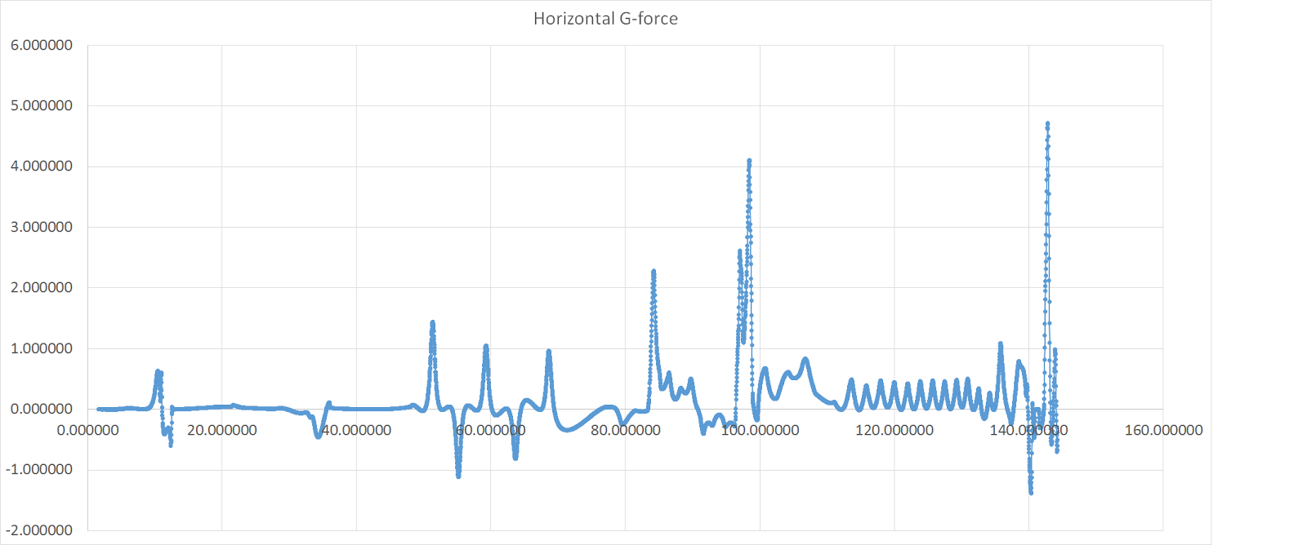

Figure : Actual horizontal G-force, at time t

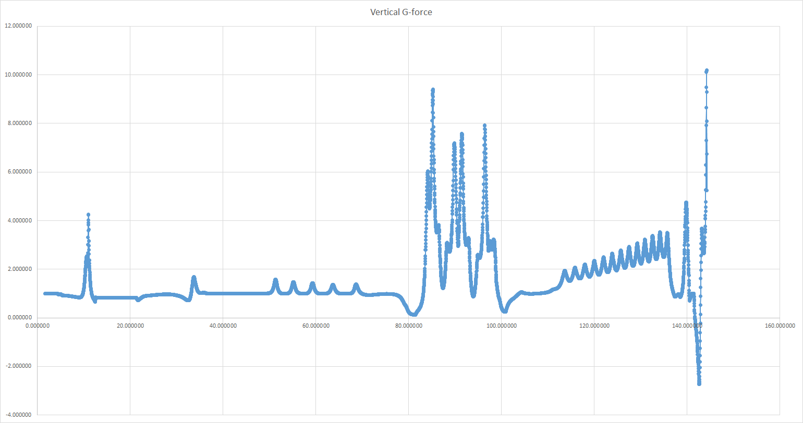

Figure : Actual vertical G-force, at time t

## 3.4 Design Validation

### 3.4.1 Provided Constraints

1. *The roller coaster shall not cover more than 1/10 of the island (238,500 m2).*
   1. *Maximum dimensions for a square: 155 cm x 155 cm*

The roller coaster design has an area of 78,300 m2.

1. *The height of the roller coaster at any point shall not exceed 300m above the terrain.*

The maximum height is 172 m.

1. *The design shall comply with all IAAPA standards.*

See section 3.4.2 IAAPA Constraints

1. *The construction and operation of the coaster should not interfere with the local ecosystem.*

Several precautions were made to ensure that the coaster has a minimum interference with the local ecosystem. To see a detailed explanation on how, see section 5.2 Potential Ecological Impact.

1. *The roller coaster should be appealing and attractive to a wide audience.*

Based on our target audience, approximately 17.4 million American households would be attracted to the coaster.

1. *A suitable and practical business plan shall be included along with the actual design.*

See section 4. Business Plan for the business plan.

1. *The model shall have the minimum dimensions of 50 cm along both the x and y directions perpendicular to each other, both parallel to the earth.*

The model dimensions are 90 cm x 78.3 cm.

1. *The base shall be made of solid wood.*

$8.75 is budgeted for the plywood baseboard.

1. *The model and coaster must be a continuous track, and must be differentiable at every point.*

At no point is the track not differentiable.

1. *The final coaster, not necessarily the design, shall be a wooden roller coaster.*

The final roller coaster will be made of treated wood.

1. *The coaster must include, along its track:*
   1. *2-loops*
   2. *1 spiral/corkscrew*
   3. *2 interlocking elements*
   4. *3 different/distinct functions (minimum 2 periods of a sine or cosine)*

As we can differentiate the spiral, the spiral counts as one of the differentiable functions.

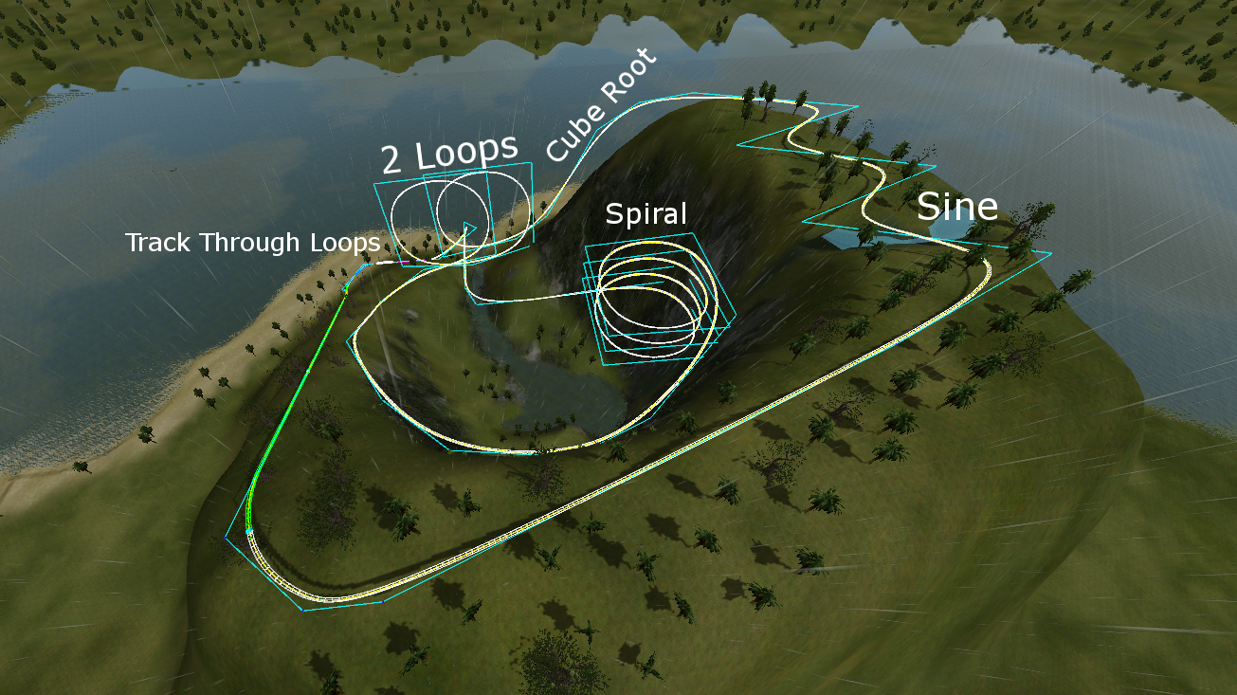

Figure : Track Design Constraints Compliance

1. *A complete blueprint must be generated.*

This is the model. Also, for specific graphs of each point, see 3.3.2 Detailed Design.

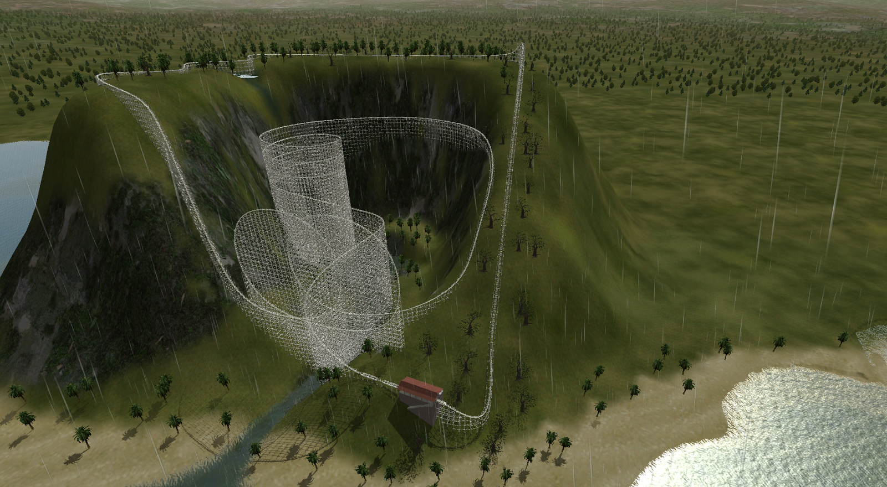

Figure : Design Blueprint

1. *At some point along the track, the cart/marble must experience at least 2Gs, and at another point less than 0.5Gs.*

This is the graph of the g forces for the entire roller coaster. At 100.81s the rider experiences 0.24Gs, and at 144.19 seconds the rider experiences 10Gs for less than 200 ms (which is safe).



Figure : Compliance of Acceleration in Given Constraints

1. *The model must reliably work with 10 consecutive activations, performed by the judges.*

Based on our calculations, the roller coaster should work 10 times consecutively. Until built, however, it is impossible to prove that it will.

1. *The model should accurately represent the topography of the construction zone.*

The model represents the topography of the area as accurately as possible.



Figure : Topography of Model

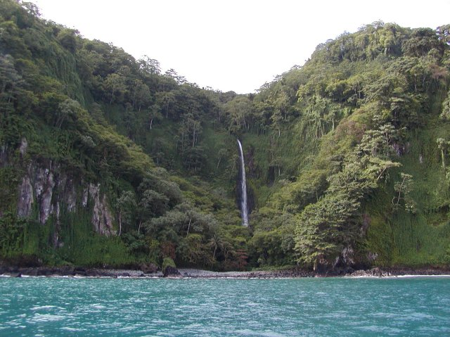

Figure : Actual Topography

1. *The track should make an optimal use of the land it’s built.*

The there is 2701.49 m of track in 78,300 m2 area. That equates to roughly 0.034 m of track per m2.

### 3.4.2 IAAPA Constraints

*These constraints were taken from another source, based on EN 13814 which is where IAAPA takes its regulations, along with ISO 9001 (both international standards, with EN 13814 being the standard for European amusement parks).*

* *5.2.1.4 Calculations shall be performed using coordinate axis and load paths as defined by Practice F 2137 or the EN equivalent, (x,y,z) ie: x and y are both parallel to the ground, perpendicular to each other, while z is vertical*

Our model and calculations follow these goals.

* *5.4.1 The designer/engineer or manufacturer shall produce and retain as-built drawings, calculations, and control software that depict the amusement ride, device, or major modification details. These drawings and calculations shall be retained for a minimum of 20 years from the date of last manufacture. In the case of a major modification, only the records associated with that major modification, and not the entire ride or device, must be retained for a minimum of 20 years.*

We are retaining these documents, with a copy in paper being delivered to the government of La Isla de Coca, a paper copy being retained in our firm, an online copy being stored on Google’s data servers, and a copy being stored in an offline server on multiple computers, and ESHS Gaming (owned by Pen Island Squad).

* *5.4.4.3 Detailed drawings of all components specifically manufactured for use in the amusement ride, device, or major modification.*

The full details, including scans and copies, will be stored in the same manner as addressed in 5.4.1

* *5.5.1 When the approval of the amusement ride, device, or major modification design is required by a regulatory authority, the following documents are typically  made available for review:* 
  + *5.5.1.1 General assembly drawings,*
  + *5.5.1.2 Facility interface drawings and related load calculations,*
  + *5.5.1.3 Operations, maintenance, and assembly instructions*

These documents, and all details under 5.5.1.* will be available, in the same fashion as described in the response to 5.4.1

* *6.3.8.3 Special tools shall not be required to operate the manual release,  unless otherwise determined by the  ride analysis.*

The release of the cart shall be simplified to dropping a marble in an easily repeatable manner, without requiring any special tools, or anymore than the simplest basic training.

* *7.1.4.5 The limits  specified for all axes are for total net acceleration, inclusive of earth's gravity. A motionless body would therefore have a magnitude of 1 G measured in the axis perpendicular to the earth's surface, and a 0 G magnitude in the axes parallel to the earth's surface.*

We are taking into consideration for the object, a constant acceleration of 1G along the Z axis, and a horizontal acceleration of 0 G by default along the X and Y axises.

* *7.1.6.1 The peak-to-peak transition time between consecutive sustained events in X and Y accelerations shall be greater than 200 ms, as measured by the time between the peaks of the consecutive events. When the elapsed time between consecutive sustained events is less than 200 ms, the limit for the peak values shall be reduced by 50 %.*

This means that any event’s maximum G-force cannot occur within 200ms of another event’s maximum G-force, unless that second G-force is less than or equal to 50% of the acceleration of the initial peak. The spacing between the events of our coaster lead to this not being an issue.



Figure : Compliance of Acceleration with IAAPA Requirements

* *7.1.7.2 Other transitions  in Z accelerations are shown in Fig. 20. The following criteria shall apply: When transitioning from sustained weightless (0 G) and more negative levels to 2 G and more positive levels, the effective onset of positive G shall be less than 15 G/s. Fig. 20 illustrates such transitions.*

In english, after any moment when Gs are less than or equal to 0, the jerk to return to positive Gs, or general jerk in the positive direction must be less than 15 G/s. As of our current model, the jerk of the entire track is less than 3G/s in magnitude.

* *7.1.8 Measurement and analysis of acceleration on amusement rides and devices shall be performed in accordance with Practice F 2137. The design acceleration levels  of the  final operational assembly of a newly developed amusement ride, device, or major modification shall be verified at commissioning. The manufacturer may verify acceleration limits herein by using either manual (for example, graphic, hand calculations, and so forth) or automatic (for example, computational, computer, and so forth) procedures.*

Acceleration values, limits, and other data was obtained through computer measurement of the roller coaster every 10ms of its trip.

* *F2291 - 06a - Fig. 11-18 Repeated From 2.2.2*

What these figures state, is that the max acceleration vertically for a duration over 200ms (or recurring peaks) must be less than 6.6 Gs, and greater than -2 .2Gs. The horizontal acceleration (relative to the rider) must be less than 6.6 Gs, and greater than -2.2 Gs, under the same time constraints. Our simulation shows that while all these limits are breached, they are not breached for more than 200ms, being impact acceleration as opposed to sustained acceleration

**See figure from constraint 7.1.6.1**

* *8.33.4.1 Inspection for damaged or missing paint and the   
  presence of moisture; any situations where water might enter and become trapped,  supporting the  development of rot or insect damage, or failure from expansion due to ice formation, and recommended methods of examinations required to determine the presence and extent of rot in timber members.*

The damage by rot or insect is prevented by the strict use of treated wood, as opposed to very weak soft wood, which is where typical damage is done. Regarding the water damage (as we are building in a rain forest, over a river and around a waterfall), we’ll also have a coated layer on each wooden piece protecting from water. On top of this, a layer of primer and paint will be on top of every visible surface.

* *13.2.2 Chain and related accessories shall be selected and designed for designer/engineer specified loads, speed, corrosion, operating environmental and dynamic conditions, and for wear and fatigue.*

We are outsourcing the design of this chain to Gold Safety and Consultation, and if the chain fails we’ll sue them for damages.

* *13.2.3 Chain manufacturer's specifications shall include dimensions, strength,  grade, and nominal breaking strength working load limit, and shall be included in the maintenance instructions.*

See 13.2.2

* *13.2.4 The capacity of the chain and related accessories, for example, terminations, adapters, shall be verifiable by certificates, manufacturer's markings, or testing.*

### 3.4.3 Ecological Constraints

* *The coaster shall not disturb any plants or animals in such a way that a decrease in population, food supply, or water supply could upset the ecosystem or endanger any plants or animals.*

The area we affect is very well optimized, with minimal support being used (running the track along more barren cliff as opposed to over more populated flat terrain). The river will not be affected in any way, not even a single support being put in the water, no flow interruptions, nothing. There will be a small upset in individual animals, but the species on the island will not be affected.

* *The coaster shall not pollute any water sources with any foreign chemicals.*

The river we cross over will not be touched, nor any waste products be dumped.

* *Only the plants necessary for building the roller coaster or rider safety shall be removed. Additionally, this number shall be kept at a minimum.*

A minimal number of trees will be removed, with the most prominent amount being at the top of the coaster before the drop down the cliff. Even here, tree removal is minimized, to preserve the environment both as a visual advantage for riders, and for conservation of nature reasons. Only where the roller coaster path goes, and where supports are necessary, will there be any trees removed.

* *The type of materials used shall not be able to affect the surrounding ecosystems.*

The primary building materials will be steel rails for holding the cart, fixed to a wooden support structure, built 100% from polished, sealed, and treated wood. The polish and seal on this wood will prevent the chemicals used in treating wood from leaking into the surrounding ecosystem.

* *The coaster shall not produce an excess of 5 tons per year of*
  + *carbon monoxide*
  + *lead*
  + *nitrogen oxides*
  + *particulate matter (TSP or total suspended particulates)*
  + *sulfur dioxide*
  + *volatile organic compounds (VOCs)*
  + *toxic air pollutant*

The only chemical noteworthy of being tracked is carbon monoxide from the generators required to operate the pullchain pulling the cart up the hill, and the air brakes to stop its descent at the end. The output that is provided will be by a motor about double the strength of the average car, yielding roughly double the annual tonnage output of a car (575 pounds), or roughly 1150 pounds annually, nowhere near the 5 ton limit.

### 3.4.4 Testing and Validation

The rollercoaster was constantly tested for speed, continuity, and g-forces. Each change was tested to ensure a positive resulted to keep the team moving forward. Each test ensured that the rollercoaster cart, a marble in the actual build, kept moving at a reasonable pace.

To ensure accuracy, the Pen Island Squad wanted to log data which could be graphed and examined by eye. Although No Limits 2 did not have the required software functionality to do so, Andrew Miyaguchi found a way to read and log the values from NL2 using software, CheatEngine, normally used to hack single player video games. Timing, xPos, yPos, zPos, Vertical G-Force, Horizontal G-Force, and Jerk was logged using a lua script every 10 milliseconds.

The logged data was then validated realtime during the rollercoaster simulations to ensure no differences, and after the simulation by a random quality check of data at random points on the track.

We’re also testing this procedure with 50 separate marbles, each weighing 4 grams, with slightly different diameters.

Table : Marble Data

|  |  |  |
| --- | --- | --- |
| Marble | Diameter | Marble Mass |
| 1 | 0.668 | 4 |
| 2 | 0.677 | 4 |
| 3 | 0.668 | 4 |
| 4 | 0.681 | 4 |
| 5 | 0.669 | 4 |
| 6 | 0.672 | 4 |
| 7 | 0.647 | 4 |
| 8 | 0.669 | 4 |
| 9 | 0.673 | 4 |
| 10 | 0.665 | 4 |
| 11 | 0.649 | 4 |
| 12 | 0.668 | 4 |
| 13 | 0.652 | 4 |
| 14 | 0.669 | 4 |
| 15 | 0.680 | 4 |
| 16 | 0.650 | 4 |
| 17 | 0.647 | 4 |
| 18 | 0.666 | 4 |
| 19 | 0.677 | 4 |
| 20 | 0.669 | 4 |
| 21 | 0.660 | 4 |
| 22 | 0.679 | 4 |
| 23 | 0.675 | 4 |
| 24 | 0.654 | 4 |
| 25 | 0.650 | 4 |
| 26 | 0.641 | 4 |
| 27 | 0.655 | 4 |
| 28 | 0.672 | 4 |
| 29 | 0.688 | 4 |
| 30 | 0.680 | 4 |
| 31 | 0.679 | 4 |
| 32 | 0.683 | 4 |
| 33 | 0.669 | 4 |
| 34 | 0.674 | 4 |
| 35 | 0.677 | 4 |
| 36 | 0.654 | 4 |
| 37 | 0.661 | 4 |
| 38 | 0.673 | 4 |
| 39 | 0.667 | 4 |
| 40 | 0.661 | 4 |
| 41 | 0.669 | 4 |
| 42 | 0.686 | 4 |
| 43 | 0.677 | 4 |
| 44 | 0.667 | 4 |
| 45 | 0.686 | 4 |
| 46 | 0.673 | 4 |
| 47 | 0.668 | 4 |
| 48 | 0.693 | 4 |
| 49 | 0.679 | 4 |
| 50 | 0.691 | 4 |

# 4. Business Case

## 4.1 Case for Change

Given the rapid growth in the Costa Rican tourism industry (aided in no small part by the opening of Jurassic Park on the Isla del Nublar), the PenIsland Squad believes that there is an unprecedented opportunity for economic development on the nearby Isla del Nublar. Currently, the Isla del Coco is designated as both a national park by the Costa Rican government and a World Heritage Site by the United Nations Educational, Scientific and Cultural Organization (UNESCO). However, the current government has expressed a desire to develop an educational theme park on the Isla del Coco in order to tap into the burgeoning tourism industry and to promote the development of STEM (Science, Technology, Engineering, and Mathematics) skills among the general populace and potential tourists.

Yet a major concern of the Costa Rican government (as well as UNESCO) is the risk of massive environmental alteration and/or devastation as a byproduct of development. It must be stated that all large economic projects have the potential for environmental and ecological hazards, given the rather extensive processes used in construction and the often unknown or unpredicted effects of development on natural processes in the affected areas. Nevertheless, the PenIsland Squad is confident in its ability to safely minimize the risk of contamination or other potentially-damaging hazards while fulfilling the educational and economic goals of the Costa Rican government and guaranteeing a sufficiently-profitable rate of return for any potential shareholders.

## 4.2 Scope

The Pen Island Squad’s purpose in building a roller coaster on the Isla del Coco is simple and straightforward: to provide the public with a means of entertainment that provides significant educational value and maintains the local environment’s integrity.  With regards to this particular design, the Pen Island Squad believes that the centrality of the Internet to contemporary popular culture provides a tremendous opportunity to increase awareness about digital innovation and provide technological context to this (relatively) recent cultural phenomenon.  Given the significant size and purchasing power of the target population (See Advertising Campaign Section), the Pen Island Squad believes that there is significant demand for a roller coaster thematically designed around the technological (software) components of the Internet.

This roller coaster will have international appeal, and is relevant to all market. STEM is a universal subject, not limited by language, and the principles and engineering concepts used and explained in the Pen Island Squad’s coaster. Educational institutions around the world can take use in this, without limits. Everyone will be interested, everyone will appreciate, and everyone will want to ride.

## 4.3 Project Implementation

### 4.3.1 External Communications and Stakeholders

In order to coordinate and harmonize relations with external stakeholders (government agencies, non-governmental officials, environmental groups, etc), the Pen Island Squad plans to initiate a public relations campaign to reassure the public of the economic benefits (jobs, private investment, tourism, etc) of the project and alleviate any potential concerns. The company will also ensure transparency by regularly released internal memos and other documents fundamental to the company’s official policy. We will maintain close relations with government agencies and non-government organizations (primarily UNESCO) through regularly-scheduled meetings and updates, and all the potential ecological impacts of the project will be thoroughly analyzed and documented by third-party inspectors and regularly released to environmental advocacy groups.

### 4.3.2 Advertising Campaign

For the advertising campaign, the Pen Island Squad hope to attract affluent tourists interested in visiting exotic tropical locales while retaining the benefits and “style” of the “First World.” The targeted audience is the typical upper-middle class household in the United States, with an estimated income of (at least) $128,000 and a minimum entertainment budget of $7,000 (or 5.4% of average household expenses). This market (estimated at nearly 17.4 million households or 14.1% of total households) may be tapped through a series of targeted national advertisements that center on the "novelty" of the Internet, as contrasted with the tropical environment. The style will mimic the post-World War II artistic style and juxtapose this "retro" perspective with the modern components of the Internet, all against the (ever-more contrasting) background of the Central American tropics. This will appeal to widespread nostalgia for the (relative) social and economic stability of the postwar era (1945-1970) in contemporary popular culture while retaining core features of modern society (primarily the Internet), providing a contextually-vibrant contrast between artistic styles of the postwar era and the social/technological foundations of the 21st century.

Assumptions:

* Reliance on consumption patterns of "average" American household.
* Minimum expense of travel and/or stay: ~$7,000
* Minimum household income: $127,951

## 4.4 Funding Arrangements

The Costa Rican government has officially granted the Isla del Coco to the Pen Island Squad; as such, the company does not have to purchase the land or pay royalties for land use. All other expenses, such as building materials, labor, etc, will be funded via a 50-50 partnership between General Electric and Google Inc.

## 4.5 Financial Appraisal

Table : Materials Cost

|  |  |  |  |
| --- | --- | --- | --- |
| Building Materials | Quantity | Unit price ($) | Subtotal ($) |
| 48x48” Plywood | 1 | $8.75 | $8.75 |
| Handles | 4 | $1.78 | $7.12 |
| Marbles (24 ct) | 3 | $5.25 | $15.75 |
| Wooden Coffee Stirrers (1000 ct) | 1 | $5.60 | $5.60 |
| Coffee Straws/Stirrers (1000 ct) | 1 | $5.05 | $5.05 |
| Soldering Iron | 1 | $93.37 | $93.37 |
| Heatgun | 1 | $34.99 | $34.99 |
| Wooden Dowels  12”x36” | 5 | $1.50 | $7.50 |
| Poultry Netting | 1 | $26.00 | $26.00 |
| Spray Paint | 1 | $4.99 | $4.99 |
|  | | | |
| Total | $209.12 | | |

Model length (100m : 3cm) - 2,701.5 m (81 cm)

Scale factor - 33,33313

Total supply cost = (Model cost * Scale factor) = (33,33313* $209.12)

Total scaled cost of materials - $6.97 million

Table : Total Construction Cost

|  |  |  |  |
| --- | --- | --- | --- |
| Name | Aggregate Cost ($) | Total Length (m) | Average cost per meter ($/m) |
| Psyclone | $8,616,814 | 1,012 | $8,514.63 |
| Colossus | $21,600,184 | 1,218 | $17,734.14 |
| Apocalypse | $10,940,863 | 884 | $12,376.54 |

Average cost (United States) - $12,875/m

Average cost (Costa Rica) - $7,210/m

Construction cost differential (Costa Rica to U.S.): 56100

Average supply cost - $2,580/m

Average total costs =Average cost (Costa Rica) - (Average supply cost * Cost differential) + Average supply cost

Average total costs = $7,210/m - ($2,580/m * 56100) + $2,580/m

Average total costs = $8,345/m

Total length of roller coaster - 2,701.5 m

Estimated total cost of roller coaster - $22.5 million

Given the disparity in lengths and costs for wooden roller coasters, averages from three notable wooden roller coasters were taken and adjusted for metric measurements. Monetary values have been adjusted for inflation.

## 4.6 Economic Appraisal

Benefits

* Increase in foreign direct investment
* Expansion of tourism industry (hotels, travel accommodations, etc)
* Increased employment in construction and tourism industries.
* Increased international recognition; easier access to foreign capital
* Sustained increase in GDP growth

Costs

* Marginal decline in ecological tourism due to displacement
* Reduction in capital stock (limits investment opportunities and govt borrowing)
* Risk of endangering endemic species
* Risk of endangering local flora (possible reduction in biomedical research)
* Risk of shrinking gene pool (limits genetic raw material for biotechnological innovation)

# 5. Ecological Impact

## 5.1 Summary

Overall, there will not be a high ecological impact in the construction, nor in the operation, of the coaster. No land outside of the immediate radius of the project shall be touched, the river running through the dig site will be unaffected and no chemicals or wastes shall be dumped. The goal is to have as little impact as possible on the terrain and vegetation, minus a minimal amount of trees that will be removed.

## 5.2 Potential Ecological Impact

Given the Isla del Coco's designation as a World Heritage Site by the United Nations Educational, Scientific and Cultural Organization (UNESCO), assuring the environmental and ecological integrity of any development project is imperative.  According to UNESCO, the Isla del Coco has little in the way of biodiversity among flora and fauna, yet possesses a large number of endemic species.  This complicates the task of minimizing the ecological impact, as special care must be taken to avoid endangering the fragile habitats of these species (which, quite literally, have no other home).

Potential ecological effects of the current roller coaster project include, but are not limited to:

*Displacement of local flora and fauna at the island's waterfall due to clearing of area and construction of roller coaster and auxiliary structures.*

Construction surrounding the area will be minimized in terms of damage to local terrain,  with minimal uprooting of the local flora. The river/waterfall itself will not be affected nor touched during construction or operation.

*Presence and/or transport of hazardous chemicals downstream via runoff, originating from building materials used in construction phase.*

The only hazardous chemicals involved during the development process derive from the concrete used in building foundations for wooden supports, which will be restricted to the immediate soil surrounding the supports, and treated wood, which will have already been sealed and polished, preventing leaking of chemicals into the river and subsequently the ocean.

*Contamination of surrounding rain forest from chemicals involved in treatment of wood.*

The wood will be sealed and polished before transport to the island, and it will be covered with a protective layer of primer and long-lasting, rain resistant paint.

*Introduction of invasive microbiological species to local environment.  May result in significant alterations in ecological web and infection of local species with parasitic microorganisms.*

The equipment brought to the island to construct the terrain is hygienic, and repeatedly scrubbed after each use to prevent microbes or other parasitic organisms from infecting this environment.

*Disruption of migratory patterns for avian and fish species along waterfall (and throughout island) due to clearing of surrounding rain forest.*

Neither the waterfall nor the river will be disrupted nor affected in anyway, and the surrounding trees will only be affected if they interfere with the support structures or imperil rider safety.

*Threatening, endangering, and/or extinction of endemic species due to clearing of traditional habitats and alteration of ecological relations (food web).*

A small area is being developed, with the impact on the land minimized, and our coaster is specifically designed to work with the land.  Other than the removal of a few birds’ nests as trees are taken down, few animals will be affected, and there will be no widespread impact on native species.

Potential measures to minimize ecological impacts include, but are not limited to:

*Optimizing area for development to minimize displacement and maximize efficiency (reduce sprawl).*

*Treat wood before transporting it to island.*

*Sterilize equipment, run health checks of workers, ensure rigorous vaccination protocols, including specifically tetanus and malaria.*

*Find ecologically-friendly alternatives to toxic/hazardous chemicals used in construction.*

*Locate and identify habitats of endemic and/or rare species; avoid areas where endemic/rare species are densely concentrated.*

*Utilize an isolated renewable power source to power the rollercoaster*

# 6. Resources

Cocos Island National Park [Internet]. [UNESCO] United Nations Education, Scientific, and Cultural Organization; c1992-2015 [cited 2015 May 15]. Available from: <http://whc.unesco.org/en/list/820>

The World Factbook [Internet]. [CIA] Central Intelligence Agency; c2015 [cited 2015 May 15]. Available from: <https://www.cia.gov/library/publications/the-world-factbook/geos/cs.html>

CPI Inflation Calculator [Internet]. [CIA] United States Department of Labor; c2015 [cited 2015 May 15]. Available from: <http://data.bls.gov/cgi-bin/cpicalc.pl>

Psyclone – Six Flags Magic Mountain [Internet]. [RCDB] Roller Coaster Database; c1996-2015 [cited 2015 May 15]. Available from: [http://rcdb.com/27.htm](http://rcdb.com/27.html)

Colossus – Six Flags Magic Mountain [Internet]. [RCDB] Roller Coaster Database; c1996-2015 [cited 2015 May 15]. Available from: <http://rcdb.com/26.htm>

Apocalypse the Ride – Six Flags Magic Mountain [Internet]. [RCDB] Roller Coaster Database; c1996-2015 [cited 2015 May 15]. Available from: <http://rcdb.com/4173.htm>

How the Average American Family Spends Their Income – And How They Trim It [Internet]. [SD] The Simple Dollar; 2014 [cited 2015 May 16]. Available from: <http://www.thesimpledollar.com/how-the-average-american-family-spends-their-income-and-how-to-trim-it/>

Number of households in the U.S. from 1960 to 2014 (in 1,000) [Internet]. [S] Statista; 2014 [cited 2015 May 16]. Available from: <http://www.statista.com/statistics/183635/number-of-households-in-the-us/>

The Business of Building Roller Coasters [Internet]. [P] Priceonomics; 2014 [cited 2015 May 18]. Available from: <http://priceonomics.com/the-business-of-building-roller-coasters/>

How Much Does it Cost to Build a Single-Family House? [Internet]. [F] Fixr; c2015 [cited 2015 May 19]. Available from: <http://www.fixr.com/costs/build-single-family-house>

Building Process [Internet]. [CR] Costa Rica; c1996-2015 [cited 2015 May 19]. Available from: <http://costarica.com/real-estate/building-process/>

Codes and Compliance: Demystifying the Door Opening [Internet]. [AADSS] ASSA ALBOY Door Security Solutions; 2014 [cited 2015 May 20]. Available from: <http://www.assaabloydss.com/Local/DSS/ASSAABLOYCodeResourceHandbook_FINAL.PDF>

Designation: F 2291 - 06a (US). 2012. Standard Practice for Design of Amusement Rides and Devices [Internet]. American Society for Testing and Materials International (US); 2006 [cited 2015 May 16]. Available from <https://law.resource.org/pub/us/code/ibr/astm.f2291.2006.pdf>

Leithold L. 1996. The calculus 7 of a single variable. 6th ed. Connors K., Geller R., Netzel D. editors. New York. HarperCollins Coll Publishers. 698 p.

Department of Ecology DE. 2012. Air Quality Fee Rules. [Internet]. [2012 Nov 30, cited 2015 May 20] Vol(1):Washington State. Available from: <fortress.wa.gov/ecy/publications/documents/173455.pdf>

United States Environmental Protection Agency . April 2000. Average Annual Emissions and Fuel Consumption for Passenger Cars and Light Trucks [Internet]. 1.US EPA; [April 2000, cited 2015 May 20] . Available from: <http://www.epa.gov/otaq/consumer/f00013.pdf>

Open-Source OS. 2015 April 26 . Cheat Engine [Internet]. 6.3.DBVM; [2015 April 26, cited 2015 May 20] . Available from: <http://cheatengine.org/index.php>

# Appendix A: Meeting Logs

**May 10**

**Time: 5 - 9PM**

**Location: Bradley’s House**

**Members:**

* Bradley
* Nick
* Elie
* Andrew

**Items Completed:**

* Decided on theme
* Created gantt chart
* Created a question document for questions
* Condensed the constraints for the project
* Researched the IAAPA (Could not find their guidelines)

**Status:**

* Still need to find the IAAPA guidelines (practically impossible to find)
* Each member will bring in a roller coaster idea for the next meeting
* Slightly behind, but will be easy to catch up
* Still need to figure out schedule for the business side

**May 12**

**Time: 5:30 - 9PM**

**Location: Bradley’s House**

**Members:**

* Bradley
* Nick
* Elie
* Andrew

**Items Completed:**

* Developed 5 ideas for the roller coaster
* Selected a design
* Started on some business case

**Status:**

* Still need IAAPA (for next meeting)
* Need to start on model and calculations

**May 15**

**Time: 5 - 9PM**

**Location: Bradley’s House**

**Members:**

* Bradley
* Nick
* Andrew
* Elie (6:30 - 9PM)

**Items Completed:**

* Tested efficiency
* Finalized design
* Almost finished model
* Started calculations
* Started business case (cost, purpose, etc.)
* Found some code document related to the IAAPA
* Started PDR
* Created a github repository

**Status:**

* Need to finish the model
* Need to finish calculations
* Need to finish the business case
* Finish PDR

**May 16**

**Time: 5 - 9 PM**

**Location: Bradley’s House**

**Members:**

* Bradley
* Andrew
* Elie
* Nick (7 - 9PM)

**Items Completed:**

* Found greatest resource on standards
* Finished model
* Documented the ASTM F2291-2006: Standard Practice for Design of Amusement Rides and Devices as required by: State of Indiana, 685 IAC 1-2-9 constraints
* Made progress on the business case
* Finished outlining the PDR
* Advertising campaign
* Added a budget document

**Status:**

* Added meeting on Monday, May 18 from 5 - 9PM
* Will start working on the PDR at the next meeting

**May 18**

**Time: 5:45 - 9PM**

**Location: Bradley’s House**

**Members:**

* Bradley
* Nick
* Andrew
* Elie

**Items Completed:**

* Tested the size of 50 marbles
* Ecological Impact
* Finished 3.1 and 3.2
* Started several other sections
* Funding arrangements
* External communications with stakeholders

**Status:**

* Need to finish PDR by tomorrow
* Monday morning: Finish testing

**May 19**

**Time: 5:45 - 9PM**

**Location: Bradley’s House**

**Members:**

* Bradley
* Nick
* Andrew
* Elie

**Items Completed:**

* Completed many portions of the PDR
* Found all the points of the coaster
* Found the acceleration of the coaster at all points

**Status:**

* Need to finish PDR by tomorrow

# Appendix B: Incident Report Logs

Because of the nature of the Incident Report, the questions to be answered depended on the type of incident. Therefore, only the questions that were answered are included below.

**May 15**

Member: Elie

Recorder: Bradley

Incident: Tardy

How tardy was he: 10 - 15 minutes

Amount of Notice: None

Excusable: Yes

Why: He took full responsibility, and is willing to compensate with his free time

Impact (1-5): 2

# Appendix C: Team Terms and Conditions

Preamble

This contact is between the members of Pen Island Squad (Bradley Gallon, Nick Mazuk, Andrew Miyaguchi, Elie Nehme) for the duration of the Roller Coaster Project assigned for AP Calculus at El Segundo High School in El Segundo, CA. This will be used to set the standards and the guidelines of operations for the team. These terms and conditions will be put into effect once every member submits a version of these conditions to either Steven Eno or Kathy Clemmer signed by both themselves and their parent.

1. Meetings

1.1 Scheduling

All meeting start and end times will be on PDT (UTC-7). The following are the guidelines when creating a meeting:

1. All meetings must be scheduled at least one week (to the day) in advanced. For instance, a meeting for any Saturday must be scheduled at latest the Saturday before that. Scheduling includes start time, end time, location, and the goals for the meeting.
2. If a member cannot attend a meeting, they must inform the rest of the team at least two days in advance. For instance, if a meeting is scheduled for any Saturday, the latest a member can inform the team is the previous Thursday.
3. If a member cannot attend the entire meeting, but can attend a portion of it, the same two-day rule applies as in the clause above.

Exceptions:

1. Before May 15, 2015, meetings can be scheduled within one day.
2. After May 26, 2015, members can inform the rest of the team within one day if they cannot attend part or all of the meeting.
3. After May 26, 2015, meetings can be scheduled within one day.
4. After May 26, 2015, members can inform the rest of the team within one day if they cannot attend part or all of the meeting.

If the meeting is a normal meeting as defined in section 1.5 Normal Meetings, then the signing of this conditions constitutes enough advanced notice and those meetings are compulsory. If a meeting is planned outside of these guidelines, then the meeting is not mandatory.

1.2 Meeting Cancellation

Meetings will only be cancelled under the following conditions:

1. Two members cannot meet and the other two decide to cancel. The meeting is not automatically cancelled if two members cannot meet.
2. The location is unavailable for use.

1.3 Tardiness

As a rule of thumb, tardiness is not allowed. A member is tardy if they arrive after the start time (even one minute), but within 15 after the start time. The clock used to determine the start time is (in this priority):

1. The school bell (if on campus)
2. Any device that regularly syncs with UTC.
3. Any other clock at the location of meeting.

1.4 Consequences for Not Attending

At each meeting, attendance and progress will be recorded for official record and the Project Manager will keep this record. If a member does not attend the meeting:

1. And they informed the rest of the group as described in Section 1.1 Scheduling, the only consequence is that they will not be noted for attending the meeting.
2. And they *did not* inform the rest of the group as described in Section 1.1 Scheduling, then their name will not be noted for attending the meeting *and* another member will fill out the Incident Report as described in Section 2 Incident Report.

If a member attends part but not all of the meeting:

1. And they informed the rest of the group as described in Section 1.1, then their name will be noted as attending the meeting along with the portion of the meeting they attended.
2. And they did not inform the rest of the group as described in Section 1.1, then their name will be noted as attending the meeting along with the portion of the meeting they attended *and* another member will fill out the Incident Report as described in Section 2 Incident Report.

If a member is tardy:

1. They will be noted as attending the entire meeting, but another member will fill out the Incident Report as described in Section 2 Incident Report.

1.5 Normal Meetings

While many meetings will be scheduled later, below is a list of all the currently scheduled meeting times:

* All Tuesdays from 5-9PM
* All Fridays from 5-9PM
* All Sundays from 5-9PM

All meetings, unless specified when the meeting is planned will occur at Bradley Gallon’s house: 526 Sierra Pl. #15, El Segundo, CA 90245 Garage.

2. Incident Report

The incident report is a place where team members can document potentially negative actions from other members. It should *not* be viewed as a place where misconduct is documented, only a place for events out of the norm. Some events, such as showing up at a meeting 1 minute late, is minor and will not affect the project as a whole; the fourth and fifth times start to become a problem. It is, however, impossible to document the fourth or fifth times as problematic if the first was not documented. Therefore, a member of the group is required to fill out the Incident Report every time an incident occurs. For the purpose of this project, an incident is defined by any of the following:

* Violating any of these terms (a new incident is created for each term that is broken)
* Incomplete work
* Unsatisfactory work (as determined by the rest of the group)
* In appropriate conduct
* Any other act that a member feels that it requires documentation

It should be noted that one and only one member should fill out the Incident Report for every incident to eliminate redundancy. In addition, it is compulsory that when a report is filled out, all the required information is provided completely and that all provided information is accurate. All recorded incidents will be provided to any judges/teachers for the project as defined by Kathy Clemmer upon their request as well as in the PDR as an appendix.

To eliminate confusion, the incident report can be found here: h[ttp://goo.gl/forms/yPd3zCKWrh](http://goo.gl/forms/yPd3zCKWrh)

3. Modification of These Terms

These terms can be modified at any time, by any member, without prior notice. However, any modifications will not become active until 48 hours after the modifications were made. Any changes made within that 48 hour time period that counteract any of the modifications will render the modifications void. The new version will have 48 hours from that point on to become effective.

Fortunately, Google keeps track of all the modifications to documents, so the official timestamp will be whatever Google provides. The most recent version of the terms can be found here: <https://goo.gl/NjPSLr>

4. Cancellation

This conditions will terminate upon the following conditions:

1. When the roller coaster project ends on June 3, 2015 at 11:30 AM PST.
2. One or more members quit the group for the roller coaster as determined by Kathy Clemmer.

Upon cancellation, all obligations and responsibilities towards the group cease with the conditions.

5. Signature

1.1 Student

By signing this form, I affirm that I have read and agree to be bound by all terms outlined in this report. I also agree to any modifications that may be made in the future as noted in 3. Modification of These Terms.

________________________________________        ___________________

*Student Signature                                          Date Signed*

________________________________________

*Student Name (Print)*

1.1 Parent

By signing this form, I affirm that I have read these terms, and agree to let my student attend all meetings as outlined in these terms and to not act in such a way as to prevent my student from complying to these terms.

________________________________________        ___________________

*Parent Signature                                          Date Signed*

________________________________________

*Parent Name (Print)*